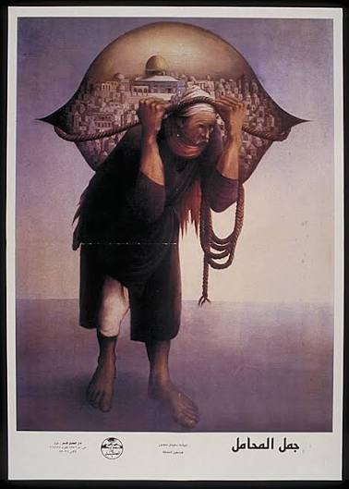
1. For a Young Visitor (Child / Teen)
Very Short:
This picture shows a man carrying a huge load — he’s carrying his home on his back. It reminds us: even when life is heavy, hope and memory keep us going.
Shorter:
Look at this artwork. The man leans forward, heavy-loaded, carrying a city-scape on his back. It’s called “Camel of Heavy Burdens” but it’s a human figure, not a camel. He carries his homeland on his shoulders. For you, this means: sometimes people bear big weights — memories, hopes, places they love. Even if it’s hard, they keep going.
2. For an Adult Visitor (General interest)
Concise summary:
This poster-image by Sliman Mansour depicts a man bearing the weight of his homeland on his back — a powerful metaphor of Palestinian resilience and memory.
Medium length:
Sliman Mansour’s “Camel of Heavy Burdens – First Printing” draws on the image of a porter carrying a city, symbolizing the enduring weight of homeland, displacement and the refusal to let go. Originally painted in 1973 and reproduced as a poster shortly after, the piece became an icon of Palestinian visual culture.
3. For a Researcher / Graduate Student
Longer:
The poster version of Mansour’s “Camel of Heavy Burdens” is a seminal object within Palestinian visual culture and the broader history of graphic arts in conditions of displacement. The original painting (1973) and its first poster printing (circa 1975) depict an elderly porter—barefoot, bent, yet steady—carrying what appears to be the city-scape of Jerusalem (including the Dome as the symbol of the town) on his back, his rope-based load tied to his forehead. MERIP
Through its iconography, the work engages with the idea of sumud (steadfastness) — staying rooted even amid exile. The poster’s circulation in the late 1970s and 1980s in Palestinian territories and diaspora makes it also a document of public expression: it moved off gallery walls into homes, walls, prints, thereby entering everyday visual life. The image invites multi-layered enquiry: how does the figure of the porter function as a metaphor for Palestinian identity? What does the burden represent (land, memory, diaspora)? From a material culture standpoint: how did the poster’s printing, distribution and location shape its meaning? From a curatorial perspective: the transition from painted canvas to poster to archive highlights the challenges of preserving visual culture under colonial/occupation conditions and in diasporic contexts.
4. For a Professor / Expert
Scholarly tone:
Sliman Mansour’s “Camel of Heavy Burdens – First Printing” occupies a crucial position in the nexus of Palestinian art, visual memory, and resistance aesthetics. The work can be read as a manifesto of sumud — the notion of steadfastness — materialized in the body of the porter, whose stooped posture yet unwavering gaze signals perseverance in the face of dispossession. As Dina Ramadan has analyzed, the painting and its subsequent poster iterations map onto Palestine’s evolving historical geography: the post-1967 occupation, the intensification of refugee experiences and the emergence of a visual lexicon of resistance. MERIP
From a curatorial-theoretical perspective, the object’s journey from painting (1973) to mass-circulated poster (1975) to digital archive invites critical reflection: how does the shift in medium affect meaning? The porter’s burden becomes not only his own but symbolic of a collective load. Moreover, the poster’s display contexts (homes, camps, public walls, diaspora centres) render visible the material and cultural strategies of Palestinian refusal and remembering. The incomplete metadata of the piece (exact print run, publisher details) also foregrounds the epistemic gaps in documenting art born of conflict zones and encampment contexts. As such, the piece serves both as an artwork and as a case-study in the challenges of museological and archival practice.
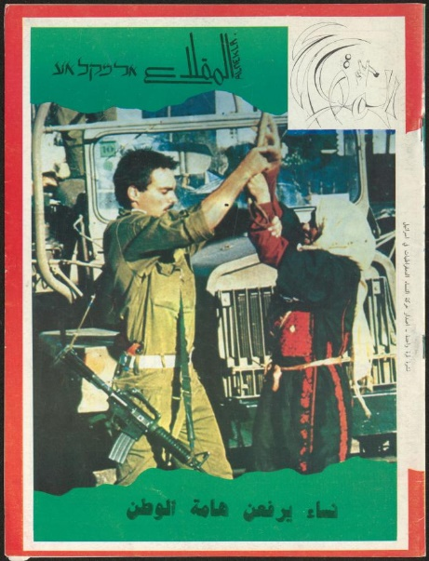
1. 👧 For a Young Visitor (Child / Teen, introductory level — “short & simple”)
Text (Very Brief, ~3 lines):
In 1988, during difficult times in Palestine, a group of brave women made this magazine to share stories about life, art, and hope. They showed how women could help their community stay strong.
Text (Mid, ~10 lines):
This magazine, called Al-Miqla', was made by Palestinian women more than thirty years ago. It talks about their work, their families, and their dreams for freedom. Inside are drawings, poems, and news about how women helped others during the First Intifada — a time when people protested for their rights. It reminds us that even in hard times, learning, art, and kindness can keep people together.

2. 👩 For an Adult Visitor (General interest, limited time — “informative but concise”)
Text (Very Brief):
Al-Miqla' was a women’s magazine published in March 1988 amid the First Intifada. It reflected Palestinian women’s voices, resilience, and activism through articles on daily life, education, and cultural identity.
Text (Medium):
This 1988 issue of Al-Miqla' was produced by the Movement of Democratic Women in Israel. It served as a platform for Palestinian women to express their views on politics, education, and community work during the early Intifada. The magazine highlighted solidarity between women across regions, addressed gender roles in national struggle, and documented artistic and social life under occupation. It offers a glimpse into how print culture connected activism and everyday life.

3. 🧑‍🎓 For a Researcher / Graduate Student (Analytical, longer, detailed)
Text (Long / Advanced):
The March 1988 issue of Al-Miqla' represents a crucial moment in the intersection of Palestinian feminist and national discourses. Published by the Movement of Democratic Women in Israel, it articulates a dual struggle: women’s emancipation and collective national liberation.
Within its pages, contributors such as Naji al-Ali and Mohammad Ali Taha discuss education, labor, and resistance through literary and journalistic forms. The issue also commemorates International Women’s Day, situating local struggles within global feminist narratives.
Al-Miqla' thus serves as a primary source for studying how grassroots women’s organizations mediated between political activism and cultural production during the First Intifada. Its multilingual readership (Arabic and occasionally Hebrew) reflects the magazine’s bridging role across communities.

4. 👨‍🏫 For a Professor / Expert (Critical, contextualized, with references)
Text (Advanced, Scholarly tone):
Al-Miqla', issued in March 1988 by the Movement of Democratic Women in Israel, exemplifies the material culture of Palestinian feminist periodicals during the late twentieth century. Emerging at the height of the First Intifada, the magazine performs a discursive function that intertwines political resistance with gender consciousness.
From a historiographical standpoint, it extends the legacy of earlier Arab women’s journals such as al-Mar’a al-Jadīda while embedding itself in a distinctly Palestinian context of occupation, displacement, and solidarity. The inclusion of figures like Naji al-Ali signals an awareness of visual satire as political critique.
Researchers may read Al-Miqla' as a textual artifact revealing the editorial strategies of women’s movements negotiating state censorship and social conservatism. Its digitization within the Walid Fahoum Collection underscores the epistemic importance of archival recovery for contemporary postcolonial scholarship.

"War and Peace" by Fatima al-Muhib – Explanatory Texts for Different Audiences
Child / Young Visitor
Many years ago, a war started in Palestine. A lot of people had to run away from their homes because of this. This poem, called "War and Peace", was written by a woman named Fatima al-Muhib. In the poem, she talks about how scary the war was – with loud bombs and gunshots – and how families like hers had to leave their towns. She also writes about hoping for peace. She dreams that one day all the people who had to leave can go back home to Palestine and live there safely. The poem shows that war is very bad, and that living in peace together is much better than fighting. It’s an important poem because it helps us not to forget about what is happening to them.
Adult / General Visitor
"War and Peace" is a short handwritten poem by Palestinian artist Fatima al-Muhib that reflects on the turmoil of 1948, the starting year of war and displacement in Palestinepalarchive.org. In simple rhyming lines, al-Muhib describes the chaos of conflict – “bombs and gunshots” falling like rain – and the fear that forced her family and many others to flee their homes. This 1948 upheaval, known as the Nakba (Arabic for “catastrophe”), saw an estimated 750,000 Palestinians expelled or compelled to flee from their towns and villagesaljazeera.com. Al-Muhib’s poem captures personal memories of that flight: she recalls running from Jericho and taking shelter in a small cottage amid the fighting. Despite the suffering, the tone of the poem is hopeful. Fatima expresses a heartfelt wish for peace in Palestine and for all the refugees to return to their landpalarchive.org. As a piece of creative testimony, this poem helps general visitors understand the human impact of the 1948 events and the enduring Palestinian longing for home and peace.
Researcher / Graduate Student
Written in the aftermath of the 1948 Nakba, Fatima al-Muhib’s "War and Peace" serves as a compelling primary document of Palestinian collective memory and resistance. The Nakba – literally “catastrophe” – refers to the mass displacement of Palestinians during the 1948 Arab-Israeli War, when roughly three-quarters of the Palestinian population (around 750,000 people) were violently uprooted from their homesaljazeera.com. Al-Muhib’s poem provides a firsthand account of that turmoil: it recounts fleeing from Jericho amid “bombs and gunshots” falling like showers, conveying the fear and chaos of war. Her narrative aligns with many contemporary eyewitness accounts and creative expressions from that period. Notably, in the immediate years after 1948, Palestinian writers and artists, often working in exile or under occupation, began to record their experiences and aspirations in literature and art. This cultural work was crucial in preserving the memory of what had happened and in cultivating a will to persevere and return despite the dispersionpalquest.org. Al-Muhib’s verse—though simple in language—encapsulates core themes of Palestinian exile literature: the trauma of displacement, the sin and senseless destruction of war, and an unyielding hope for peace and return to the homeland.
Importantly, "War and Peace" functions as more than personal reflection; it is an act of resistance through memory. By writing about her ordeal and her hopes, the author contributes to what scholars describe as the narration of memory as a form of community-building among displaced Palestinians. Literature of the Nakba era often created a shared sense of identity and purpose through storytelling, ensuring that the Palestinian catastrophe would not be forgotten. Indeed, such poems and songs kept alive the dream of return – for example, the famous lines “One Day, We Will Return” from poet Harun Hashim Rashid, which became an anthem of exilepalquest.org. Al-Muhib’s poem belongs to this body of work that affirmed the Palestinians’ right to live in peace in their own state and refusal to accept permanent loss of their homelandpalarchive.org. Preserved in the Omar al-Jallad Collection of the Palestinian Museum Digital Archive, the poem provides direct insight into the emotional and political landscape of Palestinians in the mid-20th century. It is a poignant example of how personal art and writing helped sustain national memory, identity, and resistance in the face of dispossession.
Professor / Expert
A digitized page from Fatima al-Muhib’s handwritten poem "War and Peace", preserved in the Omar al-Jallad Collection. The poem’s simple rhyming couplets belie its profound historical and cultural significance.
From a scholarly perspective, Fatima al-Muhib’s “War and Peace” is a rich artifact encapsulating the interplay of personal narrative and national history in Palestinian cultural memory. Composed in English by a Palestinian artist who directly witnessed the events of the late 1940s, the poem narrates the experience of the Nakba – the 1948 catastrophe that saw the destruction of Palestinian society and the creation of a massive refugee population. In just a few lines, al-Muhib describes the violence (“bombs and gunshots” likened to torrential rain) and the ensuing exodus (“from Jericho we ran away with refugees who found their way”), documenting the forced displacement of her community. This account corresponds to what we know from historical records: between 1947 and 1949, around 750,000 Palestinians (out of 1.9 million) were expelled or fled from their towns and villages amid the war, transforming them into refugees scattered across the regionaljazeera.com. Al-Muhib’s reference to seeking shelter in “a small cottage” during the fighting evokes the improvised and precarious refuge that many found. Her portrayal of war as “damage” and “great sin” reflects a moral repudiation of the violence that aligns with contemporary Palestinian literary responses to the Nakba. As early as 1949, poets like Fadwa Tuqan were already writing elegies and laments for the lost Palestine (“A Portrait of the Nakba”), and by the early 1950s, others such as Abu Salma (Abd al-Karim al-Karmi), Harun Hashim Rashid, and Muin Bseiso produced poems that not only mourned the homeland but also rejected the imposed reality and called for resistancepalquest.org. Al-Muhib’s work echoes this spirit, especially in its latter half where the tone shifts from describing war to envisioning peace and restoration.
Critically, “War and Peace” articulates a hope that is both political and deeply personal: “All nations for the peace must sign / To our state in Palestine. To live in peace is our right. It is much better than to fight.” In these lines, the author encapsulates the Palestinian yearning for international recognition of their rights (a peace that the nations of the world endorse) and the fundamental principle of the Right of Return. Indeed, the poem anticipates the very demand that has remained central to Palestinian discourse for decades: that refugees have the right to return to the homes and lands from which they were expelledaljazeera.com. Al-Muhib’s insistence on the justice of living in peace in Palestine dovetails with the language of U.N. General Assembly Resolution 194 (1948), which affirmed refugees’ right to return and restitution. The poem thereby serves as a grassroots voice of resistance, reinforcing through art what was being stated in diplomatic arenas – that the displacement was not accepted as final, and that return was inalienable.
Furthermore, the context of the poem’s preservation adds another layer of significance. It survives as part of the Omar al-Jallad Collection, essentially a family archive that includes Fatima al-Muhib’s writings and artworkspalarchive.org. This indicates the role of personal and familial efforts in safeguarding Palestinian heritage. Al-Muhib, born in Jericho in 1927 (and later one of the first Palestinian women to receive formal art education abroad), used both visual art and poetry to document her reality. Her decision to write this poem in English is notable; it may have been aimed at reaching an international audience or simply reflecting her educational background, but it also situates the poem within a cosmopolitan tradition of anti-war literature. The simplicity of its diction and rhyme suggests it may have been intended to be easily understood and perhaps even recited or taught, possibly to children or youth, as part of passing down the memory of 1948. In a broader cultural analysis, works like “War and Peace” exemplify how cultural production functioned as a form of sumud (steadfastness). When Palestinians are facing not only physical expulsion but also an attempt to erase their history and identity, each story, poem, or painting that records their perspective is an act of preserving truth and asserting identitypalquest.org. As one scholarly highlight notes, post-Nakba cultural activity was essential in protecting the past from being “plundered or erased” by colonial narrativespalquest.org. Al-Muhib’s poem, therefore, is not an isolated cry but part of a larger tapestry of memory work – a “primary expression of memory and resistance”. It concretizes the notion that remembrance itself is resistance: by remembering and writing about the Nakba and its aftermath, Palestinians like al-Muhib resisted the obliteration of their history and asserted their continued presence and rights.
Its preservation allows us to witness how a single handwritten page can echo the collective voice of a people determined to remember their past and reclaim their future. As one contemporary commentator observed, the very essence of Palestinian resilience and resistance is rooted in the experience of dispossessionthemarkaz.org. Al-Muhib’s “War and Peace” is a poignant embodiment of that principle – using the power of the pen to uphold memory against forgetting, and to transform the pain of loss into hope for peace and homecoming.
Sources:
- Palestinian Museum Digital Archive – Item 0305.02.0149, “War and Peace,” a Poem by Fatima al-Muhibpalarchive.org.
- Al Jazeera News (2025) – ‘One long Nakba’: Palestinians mark 77 years since mass expulsion by Israelaljazeera.comaljazeera.comaljazeera.com.
- PalQuest – Palestinian Culture and Expressions of Identity (1948–1993)palquest.orgpalquest.orgpalquest.org.
- The Markaz Review (2024) – Meditations on Palestinian Exile and Return, Dana El Salehthemarkaz.org.

‘30 March, The Day of the Land’ (1983) Poster: Explanations for Diverse Audiences
Child / Young Visitor
This is a poster about Land Day, a very special day for Palestinians every year on March 30th. On Land Day, people remember that their land is important to them. A long time ago, in 1976, many Palestinian farmers in the Galilee region were upset because some leaders wanted to take away their farms and olive groves. The farmers and their families held a big peaceful protest to say, “This land is ours!” Unfortunately, some of the people who stood up for the land were hurt – six brave protesters were killed during those marchesaljazeera.com. Now every year on Land Day, Palestinians plant olive trees and hold ceremonies to remember these farmers and show they love their landaljazeera.comfalastin.me.
Adult / General Visitor
Land Day (March 30) commemorates the 1976 protests by Palestinian citizens of Israel against Israeli plans to expropriate Arab-owned land in the Galileeen.wikipedia.orgaljazeera.com. On that day in 1976, six unarmed Palestinian demonstrators were killed and many more injured by Israeli forces during marches and strikes opposing the confiscation of thousands of dunams of their landaljazeera.comalhaq.org. Each year, Palestinians mark Land Day with protests, ceremonies and by planting olive trees to reaffirm their connection to the landaljazeera.comfalastin.me. The olive tree in particular has deep meaning: it is a long-lived, fruit-bearing tree that symbolizes Palestinian heritage, peace, and rootedness in the homelandfalastin.me.
This 1983 poster – issued by the PLO’s Information Office – was designed by artist Ismail Shammout to honor Land Daypalmuseum.org. It is based on an 1875 lithograph by British artist David Roberts. The image shows a view of Nazareth (northern Palestine) with traditional stone houses on a hillside, surrounded by olive trees and prickly pear cactuspalarchive.org. Shammout recontextualized this 19th-century “Holy Land” scene by labeling it “Nazareth – Palestine – 1875,” thus reclaiming the landscape for Palestinian history and identity.
By using an Orientalist-era image, Shammout’s poster makes a visual claim: it links contemporary Land Day struggles to a long Palestinian presence in the land. In this way the art reinforces national identity and memory.
Researcher / Graduate Student
Land Day (Yom al-Ard) is a cornerstone of modern Palestinian history and visual culture. On March 30, 1976, Palestinian citizens of Israel organized a general strike and mass marches across the Galilee in response to a government order to expropriate roughly 20,000 dunams of Arab-owned land between the villages of Sakhnin and Arrabaen.wikipedia.org. Israeli forces opened fire on the unarmed demonstrators, killing six Palestinians and wounding over a hundreden.wikipedia.orgaljazeera.com. This was the first widespread Palestinian national mobilization since 1948, and it entrenched March 30 as Land Day – an annual day of remembrance and protest for Palestinians both inside Israel and in the occupied territoriesen.wikipedia.orgalhaq.org.
Ismail Shammout’s 1983 poster “30 March, The Day of the Land” was produced under the PLO’s Unified Information Office as part of a series commemorating this anniversarypalmuseum.org. Shammout (1930–2006) is a seminal Palestinian artist whose work consistently addressed exile, resistance and national identityzawyeh.net. He himself had lived through the 1948 Nakba and the Palestinian refugee experience, and his art often depicts the refugees’ memories and aspirationszawyeh.net. In this poster, Shammout adapts a David Roberts lithograph (printed 1875) of Nazareth – originally an Orientalist “view” of Ottoman Palestine – and reframes it as part of the Palestinian national narrativepalmuseum.orgpalarchive.org.
The scene shows Nazareth’s traditional vernacular architecture: white stone houses with domed roofs or flat terraces, clustered on terraced hillsides. Surrounding the village are plentiful olive trees and a large stand of prickly-pear cactipalarchive.org. The olive tree is a potent symbol in Palestinian culture – archaeologically ancient and embedded in family life – representing deep roots and continuityfalastin.me. Poet Mahmoud Darwish famously wrote, “If the olive trees knew the hands that planted them, their oil would become tears,” capturing the tree’s link to memory and homelandfalastin.me. Cacti (sabr in Arabic) likewise symbolize resilience and patience in a harsh environment. By prominently depicting these plants, the poster explicitly ties the Land Day struggle to the land itself and to Palestinian rural heritage.
Roberts’s original lithographs have been analyzed as artifacts of 19th-century Ottoman Palestinelink.springer.com – technically Orientalist images, but also recordings of the landscape and built environment of that era. Shammout’s reuse of Roberts’s image thus subverts its colonial origins: he re-inscribes the scene with a Palestinian title and adds the Land Day slogan. This act “appropriates” Orientalist visual material and reclaims it as national heritage. In doing so, the poster situates the 1976 protests within a historical continuum: it visually asserts that Palestinians were living in and cultivating Nazareth long before modern conflicts, thereby reinforcing the argument for enduring land rights.
Politically, the poster ties together memory, resistance and identity. Land Day itself is a moment of collective memory, linking the victims of 1976 to a century of dispossession and resistance in Palestinealhaq.orgalhaq.org. By commemorating Land Day, the poster contributes to the politics of memory: it reminds Palestinians (and others) of a narrative of injustice and perseverance. The text and image work together to communicate that the people of Nazareth/Palestine have claimed and defended this land as their own. Through its art-historical and nationalist layers, the poster exemplifies how cultural production can cement a national identity rooted in specific places and histories.
Professor / Expert
“30 March – The Day of the Land” is a rich example of Palestinian visual-political discourse. Land Day (Yawm al-Arz) itself must be understood within the broader settler-colonial context of Israel’s creation and expansion. In March 1976, the Israeli government announced plans to expropriate tens of thousands of dunams in the Galilee, as part of a deliberate policy to “Judaize” the regionen.wikipedia.orgalhaq.org. The response – a general strike and mass rallies by Arab citizens of Israel – culminated in what historians call a pivotal moment of Palestinian nationalization within Israel. Six Arab protesters were killed by Israeli police in Nazareth and Sakhnin, and over a hundred woundedaljazeera.comalhaq.org. Scholars note that Land Day functions not only as an act of protest but as a form of counter-memory, connecting contemporary resistance to the “mass forcible displacement” of the 1948 Nakba (in which 85% of indigenous Palestinians were expelled) and to continuing expropriationsalhaq.orgen.wikipedia.org.
Ismail Shammout’s poster engages this history at multiple levels. Visually, it repurposes a mid-19th-century lithograph by David Roberts, an image originally intended for a European audience fascinated by the “Holy Land”palmuseum.orglink.springer.com. By rebranding it “Nazareth – Palestine – 1875,” Shammout asserts a Palestinian cartography: Nazareth is emphatically identified as Palestinian territory in the Ottoman era. The poster’s aesthetic – toned parchment background, border framing, clear typeface – evokes a document of historical record. In graphic design terms, it simultaneously serves as a remembrance (like a historical photograph) and as political propaganda (being issued by the PLO’s Information Office).
Critically, the iconography is loaded. The town’s white-washed buildings (with characteristic domes and cisterns) recall traditional Palestinian rural architecture, highlighting continuity from Ottoman times to the present. The surrounding olive groves are more than scenery: they explicitly signal a cultivated homeland. In Palestinian cultural memory, olive trees embody heritage and defiance against uprootingfalastin.me. Indeed, planting olive trees has become a ritual act on Land Day, symbolizing peace and return. As a UNESCO-affiliated observer notes, olive trees are “universal symbols of peace and Palestinian rootedness in their land”embraceme.org. Likewise, the cactus (sabra) has patriotic overtones: the Arabic sabr means patience or endurance, and Palestinians have long associated the hardy cactus fruit with native perseverance. Although not explicitly cited in the sources above, this motif figures in Palestinian art (see, e.g., “[Patience] as Resistance” in contemporary exhibits).
Shammout himself was a self-conscious architect of Palestinian art-activism. A founding figure in Palestinian modernism, he explicitly stated that his work “never ceases depicting the Palestinian exodus” and that dispossession, dream of return, and “the dignity and pride” of his people formed “the soul of his art”zawyeh.net. In this poster, Shammout extends that mission: he layers the memory of 1948, 1967 and 1976 into one image. The caption (not shown in our sources but present on the poster) likely reads in both Arabic and English, bridging local and global audiences. By evoking 1875 Nazareth, the poster makes a discursive claim: despite modern expulsions and fragmentation, the Palestinian people remain “inseparable as a whole” across time and placealhaq.org. In the vocabulary of settler-colonial studies, Shammout’s artwork re-narrativizes space – reclaiming the visual archive of Palestine as our history.
In sum, “30 March – The Day of the Land” integrates art, memory and politics. It stands as an example of how visual culture sustains national identity under occupation. As Al-Haq notes, Land Day’s legacy is that Palestinians continue to resist in hopes of “dominating the whole land of historic Palestine with the least [settler] population,” a “ruthless” colonial aimalhaq.org. The poster contests this aim by affirming that historical Palestine included cities like Nazareth with an active Arab presence. By connecting a 19th-century landscape to a 20th-century political event, Shammout’s design asserts that the struggle for land rights and the act of remembrance are themselves acts of identity formation. It reminds viewers that land, memory and resistance are inseparable in the Palestinian narrativealhaq.orgfalastin.me.
Sources: Information above is based on analysis of the poster’s details and historical contextpalmuseum.orgpalarchive.orgaljazeera.comen.wikipedia.orgalhaq.orgfalastin.mezawyeh.net.

Poster Title: Our Cause / The Palestine Cause (Original Arabic: قضيتنا تحرر وطني وعودة وتقرير مصير).

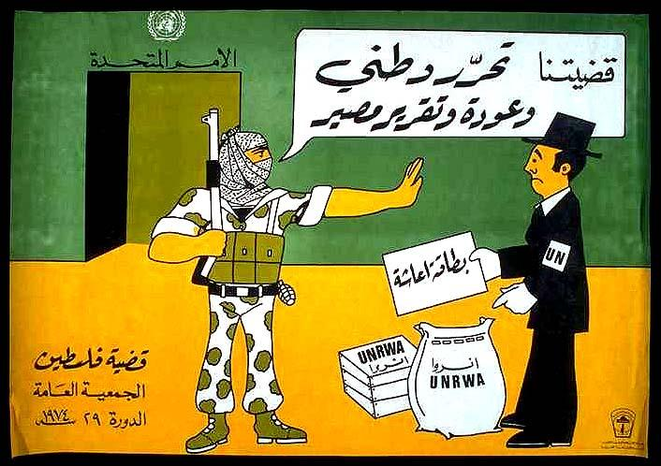

- Child / Young Visitor

Short version (3–4 lines):
This picture shows a Palestinian fighter saying “No!” to a man from the United Nations. The fighter says that his cause is to free his homeland and go back home — not to take food or papers from others. It tells us that freedom and home are more important than just help.

Mid-length version (about 8–10 lines):
In this drawing, a Palestinian freedom fighter stops a man wearing a hat that says “UN.” The man offers food and help marked “UNRWA,” but the fighter says: “Our cause is the liberation of our homeland and the return of our people.” That means: “We want to go home, not only get aid.”
This poster was made a long time ago, when many Palestinians lived in refugee camps after losing their homes. The fighter’s clothes and strong voice show pride and hope. The picture teaches that people want justice and freedom, not only charity.
- For an Adult Visitor (General interest)
Concise explanation:
The 1970s Palestinian poster “Our Cause” depicts a fedayee (freedom fighter) rejecting UNRWA aid from a United Nations representative. The fighter’s words “Our cause is the liberation of our homeland and the return of our people” assert that political freedom, not humanitarian assistance, defines the Palestinian struggle [1].
Medium explanation:
“Our Cause” (قضيتنا) is a political poster that appeared during the 1970s, distributed by the Palestine Liberation Organization’s Information Office. In the image, a Palestinian fighter halts a UN official offering aid marked “UNRWA.” The Arabic text in the speech bubble reads: “Our cause is the liberation of our homeland and the return of our people” [1].
The scene visualizes a critique of international aid agencies, especially UNRWA, suggesting that relief efforts risked replacing the demand for justice and return with dependency and charity. The poster expresses the PLO’s message of that era: the issue of Palestine was not a “refugee problem” but a national liberation movement [2].

For a Researcher / Graduate Student

The poster “Our Cause” (قضيتنا) belongs to the political graphics tradition that emerged from the PLO’s visual campaigns of the 1970s. Produced under the PLO’s Unified Information Office, it presents a clear ideological argument: the Palestinian struggle must be understood as a fight for national liberation, not a humanitarian crisis [3].
In the image, a fedayee,a symbol of resistance and masculine steadfastness (sumud), blocks a United Nations delegate offering UNRWA aid. The text in the speech bubble, “Our cause is the liberation of our homeland and the return of our people,” reframes the Palestinian question as one of decolonization rather than relief [1].
By depicting the UN official as well-meaning but misguided, the poster articulates a critique of international bureaucracies that depoliticize Palestinian suffering. UNRWA’s refugee camps, food rations, and identification cards are visually juxtaposed with the fedayee’s rifle, uniform, and refusal gesture, marking the contrast between dependency and self-determination [2].
Such posters circulated widely in camps, universities, and PLO offices, and functioned as instruments of popular education and mobilization [3]. They helped consolidate a collective identity grounded in resistance, rejecting the reduction of Palestinian peoplehood to a humanitarian file [4].

For a Professor / Expert

The poster “Our Cause” (قضيتنا) exemplifies the rhetorical and semiotic strategies of PLO-era propaganda art, where graphic design served as an instrument of ideological education. Emerging from the late 1970s context of the UN General Assembly’s annual “Question of Palestine” sessions, the image encodes the tension between international humanitarianism and anti-colonial liberation discourse [2].
Formally, the composition is didactic: the armed fedayee—rendered in camouflage, kaffiyeh, and resolute posture—occupies the visual and moral high ground, while the UN official, caricatured in Western attire, proffers aid packages labeled “UNRWA.” The spatial arrangement visually situates the United Nations as external to the Palestinian space of struggle [3,4].
Textually, the Arabic phrase “قضيتنا تحرير وطني وعودة و تقرير مصير” (“Our cause is national liberation, return, and self-determination”) summarizes the PLO’s programmatic triad. In this sense, the poster translates political doctrine into visual pedagogy [3].
The work’s anti-humanitarian critique anticipates scholarly debates on the depoliticization of Palestinian identity through relief structures. As Anne Irfan notes, UNRWA’s operations produced “an institutionalized refugeehood” that the PLO sought to transcend by reasserting political agency [2].
The poster thus participates in a discursive struggle over representation: whether Palestinians are global subjects of charity or revolutionary agents of liberation [4].

Sources

[1] Palestine Poster Project Archives – “Our Cause”: https://www.palestineposterproject.org/posters/our-cause

[2] Anne Irfan, “Palestine at the UN: The PLO and UNRWA in the 1970s”, Institute for Palestine Studies: https://www.palestine-studies.org/en/node/1649968

[3] PalQuest – “The Palestinian Poster”: https://www.palquest.org/en/highlight/10528/palestinian-poster

[4] Loophole Art – “Palestinian Revolutionary Posters: Voices of Resistance and Resilience”: https://loophole.art/articles/palestinian-revolutionary-posters

Poster Title: 'Steadfastness' (Salah Al Atrash, 1980)

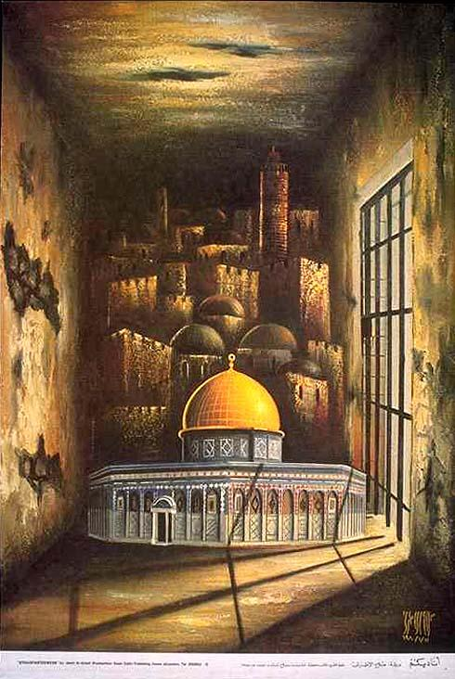
- Child / Young Visitor

Short version:
This poster shows a golden‑dome building, a special and important place, inside a large dark room, light shines from a barred window. The title “Steadfastness” means staying strong and refusing to give up.
The image tells us that even when things get dark and scary, people can remain firm, keep hope alive, and protect something important.
Mid‑length version:
In the poster titled “Steadfastness”, we see a building with a golden dome, which many people around the world recognise as a symbol of a sacred place, placed inside a sombre room, with strong shadows and light streaming from a barred window.
The word “steadfastness” means maintaining determination and refusing to be moved. The picture invites the viewer to think of the building (and what it stands for) as something that must be held onto, even in hard times.
When your home, your culture or your beliefs are threatened, you can choose to stand firm rather than abandon them. It’s a visual message of hope and courage, not just sadness.

For an Adult Visitor (General interest)

Concise explanation:

The poster “Steadfastness” conveys the theme of endurance in the face of adversity. It uses the architectural symbol of the golden‑dome shrine set within a shadowy interior to express the idea that cultural or spiritual identity must be preserved even under confinement and threat [1].
Medium explanation:

“Steadfastness” shows a building with the Dome of the Rock in Jerusalem within a room whose walls and barred window create a sense of imprisonment or siege. The juxtaposition of sacred architecture and confinement evokes a message of determination: one must remain firm, maintain hope, and refuse to surrender one’s rights or heritage.
In the broader context of Palestinian visual culture, such posters serve as expressions of resilience and identity. They remind the viewer that the struggle is not only external but also symbolic: keeping alive memory, place, and sovereignty even when circumstances are dark [2].

For a Researcher / Graduate Student

The poster “Steadfastness” functions as a visual articulation of the Palestinian concept of sumūd (steadfastness) the ethos of enduring and persisting amid dispossession, occupation, and exile [1].
The representation of the golden‑dome shrine, the Al‑Aqsa Mosque/Temple Mount, within a barred chamber creates an allegory of containment: sacred space rendered captive, yet illuminated.
From a semiotic perspective, the contrast between dark surrounding walls and the illuminated dome emphasises moral inversion: what appears physically confined (the shrine) becomes spiritually elevated. The barred window allows light, signifying hope and transcendence.
This poster can be placed within the tradition of Palestinian poster art (1960s‑1980s) where graphic design was mobilised for political education, self‑assertion, and popular mobilisation [2]. As one commentary notes, Palestinian posters “provided a way to rebel, maintain hope, and sustain a collective identity” [2].
In museum or archival terms, the poster underscores how art becomes a site of memory and resistance. The viewer is compelled to reflect: who is being imprisoned — the space, the people, the idea? And what does it mean to remain steadfast when the walls are closing in? [3].

For a Professor / Expert

The poster “Steadfastness” is a paradigmatic example of how Palestinian graphic art deploys architectural iconography and spatial metaphor to convey political subjectivity [1].
The golden dome—likely referencing Jerusalem’s Islamic shrine—serves symbolically as locus of national and religious aspiration, while the surrounding environment (a confined, barred room) evokes themes of occupation, siege, and containment.
In presenting a sacred structure within a carceral setting, the poster collapses the dichotomy between sanctuary and captivity, thereby articulating an aesthetics of sumūd, resistance not through overt conflict but through remaining rooted and refusing displacement.
The barred window admits light, signalling not concession but defiant hope [2].
The poster also participates in a longer genealogy of PLO-era poster art (1960s‑80s), wherein mass‑reproduced graphics became pedagogical tools for articulating a narrative of liberation and return. As one analysis observes, posters of this genre “formed a testament to the resilience of a people … providing hope for liberation and peace” [2].
In terms of visual methodology, the composition’s chiaroscuro, spatial framing, and symbolic minimalism invite semiotic unpacking: the viewer is positioned both outside and inside; the sacred is framed as vulnerable yet luminous.
This duality invites reflection on the political ontology of place under occupation. For archival and curatorial praxis, “Steadfastness” illustrates how ephemera of mass distribution (posters) acquire long‑term cultural value. They mediate between temporal events (conflict, exile) and enduring identities (home, memory) [3].

Sources

[1] Palestine Poster Project Archives – “Steadfastness”: https://www.palestineposterproject.org/posters/steadfastness-0

[2] Loophole Art – “Palestinian Revolutionary Posters: Voices of Resistance and Resilience”: https://loophole.art/articles/palestinian-revolutionary-posters

[3] EastSide Arts Alliance – “If Every Poster Was a Stone: Palestine Prints to Intervene, Disrupt, and Confront”: https://www.eastsideartsalliance.org/exhibitions-archive/if-every-poster

Poster Title: “He Who Plunders Others Always Lives in Terror,” a Poster by OSPAAAL (1975)

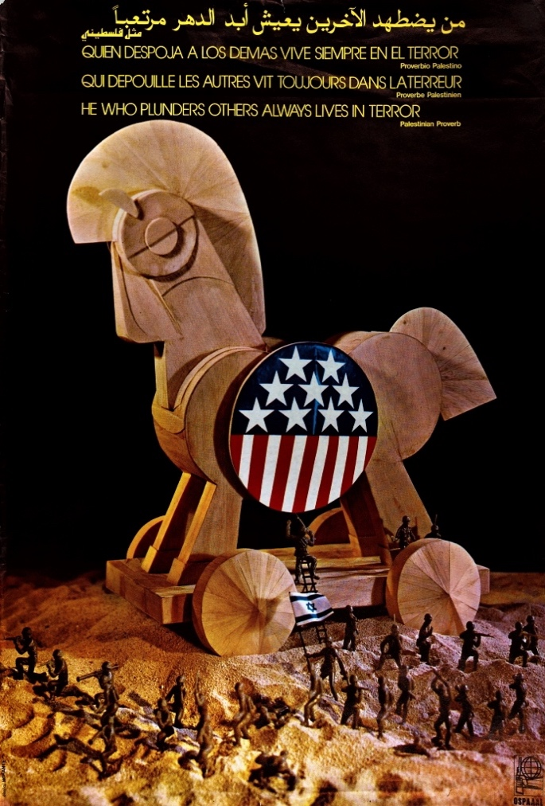

- Child / Young Visitor

Short version:
This poster shows a big wooden horse with small soldiers around it. It tells a story about unfairness and trickery, that when someone takes from others, they end up living in fear themselves [1].

Mid‑length version:
This poster shows a huge wooden horse painted with the U.S. flag. From inside the horse, tiny soldiers carrying another flag are coming out. It comes from the story of the Trojan Horse, when an army hid inside a wooden horse to fool their enemies. The artist used this old story to show something new: how one country can use another to do harm. The words at the top say, “He Who Plunders Others Always Lives in Terror.” It means that people who steal or hurt others can never feel peaceful. The artist made this picture to remind us that being fair and kind is stronger than lies and power [1].

For an Adult Visitor

Titled “He Who Plunders Others Always Lives in Terror,” this poster was created by the Organization of Solidarity with the Peoples of Asia, Africa and Latin America (OSPAAAL) in Havana during the mid-1970s [1][2]. The artwork depicts a wooden Trojan Horse decorated with the U.S. flag, from which miniature Israeli soldiers emerge. The design turns the ancient myth into a modern warning: Israel appears as the Trojan Horse of U.S. imperialism in the Middle East [3]. The proverb, printed in Arabic, Spanish, French, and English, is described as Palestinian, and its message, that those who plunder others are consumed by fear, conveys a universal moral. The piece reflects the global solidarity between revolutionary movements and the Palestinian struggle for liberation [1][4].

For a Researcher / Graduate Student

The poster “He Who Plunders Others Always Lives in Terror” (1975) is a quintessential example of tricontinental revolutionary art. Produced by OSPAAAL in Havana, it situates the Palestinian question within the global framework of anti-imperialist struggle [2][3]. The visual metaphor, a U.S.-flagged Trojan Horse releasing Israeli troops, fuses classical myth with Cold War political symbolism. It presents Israel as the hidden instrument of American power in the Arab world, dramatizing how imperialism operates through deceit and proxy [3].

The proverb, printed in four languages, embodies OSPAAAL’s mission to connect liberation movements across Asia, Africa, and Latin America [1][2]. Distributed globally through Tricontinental magazine, the poster’s multilingual design turned political art into a medium of shared resistance [5]. Visually, its crafted wood textures, staged lighting, and miniature soldiers evoke a theatrical allegory: a world of power plays and illusions. Within Palestinian poster history, it stands as a transnational extension of the resistance aesthetic, merging Latin American revolutionary design with Arab anti-colonial meaning [1][4].

For a Professor / Expert

OSPAAAL’s “He Who Plunders Others Always Lives in Terror” (Havana, 1975) embodies the visual discourse of tricontinentalism, a Cold War solidarity ideology uniting liberation movement across the Global South [2][3]. The poster’s use of the Trojan Horse allegory encodes a dual critique: U.S. imperial power disguised as friendship and Israel’s role as its military extension in the Middle East. The horse, rendered in geometric wooden forms bearing the American insignia, conceals miniature Israeli soldiers descending onto desert terrain, a metaphor for proxy warfare and occupation [1][3][5].

The multilingual inscription “He Who Plunders Others Always Lives in Terror”, operates as both political slogan and moral axiom. Presented in Arabic, Spanish, French, and English, it materializes OSPAAAL’s translingual strategy of global communication [1][2][4]. The phrase, identified as a Palestinian proverb, inverts colonial hierarchies of fear: the oppressor becomes the haunted subject, recalling Frantz Fanon’s reflections on the colonizer’s anxiety in “The Wretched of the Earth” (1961) [6].

As an object, the poster merges propaganda and fine art. Its staged composition, meticulously photographed rather than painted, demonstrates OSPAAAL’s sophisticated use of set design to produce political allegory. By circulating through Tricontinental magazine, the work joined what David Kunzle calls a “visual postal network of revolution,” transmitting aesthetic and ideological solidarity across continents [5][7]. In Palestinian visual historiography, it signifies the global diffusion of sumud (steadfastness) as a visual ethic: resistance not through weapons but through image, memory, and transnational alliance [4]. Now preserved in the Palestinian Museum Digital Archive (Item 16482), the poster remains a vital record of how global visual culture reinforced the moral and political foundations of the Palestinian cause [1].

Bibliography / Sources

[1] Palestinian Museum Digital Archive, “He Who Plunders Others Always Lives in Terror,” OSPAAAL poster (ca. 1975), Item 16482. https://palarchive.org/index.php/Detail/objects/16482/lang/en_US

[2] OSPAAAL (Organization of Solidarity with the Peoples of Asia, Africa and Latin America), Tricontinental Magazine, Havana (1970–1978).

[3] Palestine Poster Project Archives, entries on OSPAAAL and solidarity posters. https://www.palestineposterproject.org

[4] Cuban Tricontinental Institute of Solidarity, He Who Plunders Others Lives in Terror (Poster text analysis), Havana, 1975.

[5] Kunzle, David. “The Posters of OSPAAAL: Art of Solidarity.” Tricontinental Journal of Visual Culture, 2018.

[6] Fanon, Frantz. The Wretched of the Earth. New York: Grove Press, 1963.

[7] Maasri, Zeina. Off the Wall: Political Posters of the Lebanese Civil War. London: I.B. Tauris, 2009.

Photo Title: Hisham Halwani and Others, 1964

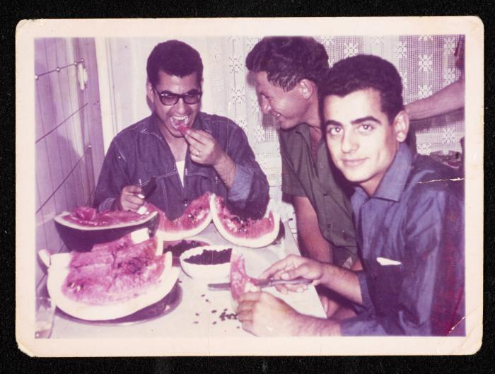

- Child / Young Visitor

Short version:
This photo shows three friends sharing slices of watermelon. They look happy, laughing, and enjoying a simple meal together [1].

Mid‑length version:
Here, three men sit at a table filled with watermelon. One of them smiles while eating, another looks toward his friends, and the third turns to the camera. The picture shows something important: even when life is difficult, people find joy in small, shared moments. Watermelon, a favorite summer fruit in Palestine, often means friendship, hospitality, and home. This image reminds us that ordinary life, laughter, and friendship are also part of history, not just war or sadness [1].

For an Adult Visitor

Taken in Jerusalem in 1064, this color photograph depicts three young men sitting at a small table, laughing and sharing watermelon. It comes from a private family collection preserved in the Palestinian Museum Digital Archive [1]. The casual setting, plain walls, lace curtains, and a shared plate, suggests domestic intimacy. The image contrasts sharply with dominant representations of Palestinians as refugees or militants; instead, it affirms normal life, humor, and friendship. Watermelon has also become a cultural symbol: its red, green, white, and black colors recall the Palestinian flag, and its presence in art and protest later came to represent identity and resilience[3]. This photo, however, predates that symbolism, it shows the fruit simply as part of ordinary life, a quiet testimony of joy amid history.

For a Researcher / Graduate Student

This photograph, catalogued as “Hisham Halwani and Others” (Palestinian Museum Digital Archive, Item 245273), belongs to the vernacular photographic tradition of mid-20th-century Palestine [1]. Taken in Jerusalem in 1964, the picture shows three men in casual attire, seated around a table with several sliced watermelons. One smiles at the camera, another eats, and a third looks toward his friend. Their relaxed posture and laughter evoke a domestic setting rather than a studio portrait.

From a historical perspective, this image exemplifies the private, human dimension of Palestinian modernity, capturing leisure and companionship in the post-Nakba decades. Unlike photojournalistic imagery centered on conflict or exile, such domestic photographs construct a counter-archive of everyday life, what anthropologist Ann Laura Stoler would call “the archive of intimacy” [3].

Thematically, the watermelon carries layered meanings. In later decades, particularly after the 1967 occupation, the fruit became a political emblem because its colors mirror those of the banned Palestinian flag [2]. In this earlier context, however, its appearance is purely social, a seasonal ritual, tied to family gatherings and hospitality. As scholars of Palestinian visual culture note, domestic photography from this era often reflects subtle assertions of normalcy and dignity despite political precarity [4]. This image thus functions as a site of visual resistance: it insists that Palestinian identity is not reducible to suffering, but also grounded in laughter, taste, and togetherness.

For a Professor / Expert

The photograph “Hisham Halwani and Others” (Palestinian Museum Digital Archive, Item 245273) invites interpretation at the intersection of vernacular photography, affective historiography, and visual resistance. Captured in 1964, the color snapshot depicts three men in a domestic setting, sharing watermelon at a modest table. The apparent spontaneity of the image, informal poses, casual clothing, unposed gazes, situates it within what Marianne Hirsch terms “postmemory’s family frames”: visual forms that transmit affective and cultural memory across generations [5].

Archival context reveals the photo as part of a private collection rather than an institutional record [1]. As such, it participates in the formation of a counter-archive of Palestinian everyday life. Against the dominant global visual economy that has long represented Palestinians through war, displacement, or humanitarian crisis, this photograph asserts an alternative temporality: one of leisure, friendship, and domestic joy.

Symbolically, the watermelon operates on two registers. First, as a pre-political object, a fruit of summer, abundance, and sociability; second, retrospectively, as an unintentional prefiguration of later nationalist iconography. Following the 1967 occupation, the display of the Palestinian flag was outlawed by Israeli authorities, and artists began using the watermelon’s colors as surrogate national symbols [2]. In this sense, the image retrospectively acquires layers of cultural and political significance.

From a curatorial standpoint, its digitization within the Palestinian Museum Digital Archive exemplifies the institutional commitment to salvaging vernacular memory as part of decolonial museology [1][4]. The photo, mundane yet profound, thus performs a dual function: it restores visibility to ordinary Palestinian lives and challenges the reduction of Palestinian subjectivity to trauma. In visual theory terms, it represents what Ariella Azoulay calls “the civil contract of photography” an ethics of seeing that connects the photographed, the photographer, and the viewer in a shared recognition of existence [6].

Bibliography / Sources

[1] Palestinian Museum Digital Archive, “Hisham Halwani and Others,” 1964, Item 245273. https://palarchive.org/index.php/Detail/objects/245273/lang/en_US

[2] Adam Sella, “The fruits of Palestine and their symbolism”, Al Jazeera, 31 Aug 2023- https://www.aljazeera.com/news/2023/8/31/the-fruits-of-palestine-and-their-symbolism

[3] Stoler, Ann Laura. Along the Archival Grain: Epistemic Anxieties and Colonial Common Sense. Princeton University Press, 2009.
[4] Shehadeh, Raja. Palestinian Walks: Notes on a Vanishing Landscape. Profile Books, 2008.
[5] Hirsch, Marianne. Family Frames: Photography, Narrative, and Postmemory. Harvard University Press, 1997.
[6] Azoulay, Ariella. The Civil Contract of Photography. Zone Books, 2008.

Photograph: 'Clashes between a Child and the Occupation Forces in Al‑Bireh'

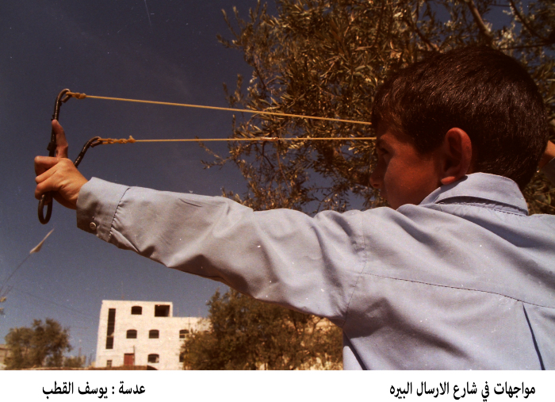

- Child / Young Visitor
Short version:
In this picture, we see a young boy holding a slingshot and facing off against soldiers. It’s a moment of conflict, showing that even kids sometimes feel they must defend themselves [1].
Mid‑length version:
This photograph, titled “Clashes between a Child and the Occupation Forces in Al‑Bireh,” comes from the Palarchive (Yousef al‑Qutob Collection). It shows a child using a slingshot during confrontations with soldiers [1][2].
The image powerfully conveys how children are not only bystanders, sometimes they become involved in tough and dangerous moments. It reminds us that conflict affects all ages, not just adults [7].

For an Adult Visitor

Taken from the Yousef al‑Qutob Collection and preserved in the Palestinian Museum Digital Archive, the image shows a child brandishing a slingshot during violent altercations on Al‑Bireh Street, presumably with Israeli occupation forces [1][2].
The photo was documented by al‑Qutob, a journalist for WAFA. Such imagery reveals how Palestinian children are often drawn into confrontations, illustrating the lived reality of occupation and protest at the street level [4][6].
It also raises awareness of how humanitarian organizations report on the psychological and social consequences of militarized environments on Palestinian youth [4][5].

For a Researcher / Graduate Student

The photograph “Clashes between a Child and the Occupation Forces in Al‑Bireh” (Palarchive object 0100.01.0591) derives from the Yousef al‑Qutob Collection, archived by the Palestinian Museum Digital Archive [1][2].
The image frames a boy aiming a slingshot, a symbol of asymmetrical resistance and improvisational protest, against an unseen adversary. The act evokes the ethics of representation and the intergenerational dimension of resistance [6][7].
From a visual‑semiotic standpoint, the slingshot symbolizes material scarcity and moral strength. It marks the “David vs Goliath” dynamic that recurs across Palestinian protest imagery, representing self‑defense under conditions of occupation [4][6].
Scholars such as Defense for Children International – Palestine have documented how military encounters expose children to systemic violence and trauma while shaping social identity [4].
In the broader corpus of Palestinian visual culture, this photograph functions as both record and metaphor: the child’s gesture embodies sumūd — steadfastness — while also inviting reflection on the ethics of photographing minors in conflict [5][6][7].

For a Professor / Expert

The photograph “Clashes between a Child and the Occupation Forces in Al‑Bireh” occupies a critical position within the visual archive of Palestinian resistance. Housed in the Yousef al‑Qutob Collection (Palarchive object 0100.01.0591), it exemplifies the convergence of documentary practice and political testimony [1][2].
As an image, it articulates a politics of visibility: the Palestinian child not as passive victim but as embodied agent of dissent. The use of the slingshot , a recurrent icon in Palestinian resistance art, recodes vulnerability as defiance [6].
From a representational theory perspective, the composition performs a visual reversal: the child’s body, poised and intentional, occupies the foreground; the militarized power remains unseen. This absence displaces the spectacle of violence, compelling the viewer to confront asymmetry through imagination rather than spectacle [6][7].
Interdisciplinary analyses (B’Tselem 2000; DCIP 2023) stress the ethical tension inherent in documenting such moments: photography both exposes injustice and risks aestheticizing suffering [4][6]. The photo thereby engages what Azoulay terms “the civil contract of photography,” where viewing entails responsibility toward the subject [4].
Contextually, the photograph’s production aligns with intensified confrontations in the West Bank during the late 1980s and early 1990s, as documented by Al‑Haq and WAFA [2][5]. Within that historical frame, Al‑Bireh emerges as a locus of youth‑led resistance and international media attention.
Thus, this image serves not merely as reportage but as a locus of epistemic negotiation, between innocence and militancy, documentation and advocacy, anchored in the lived realities of occupation [4][5][6][7].

Sources

[1] Palestinian Museum Digital Archive / Palarchive – “Clashes between a Child and the Occupation Forces in Al‑Bireh”: https://www.palarchive.org/index.php/Detail/objects/90066/lang/en_US

[2] Yousef al‑Qutob Collection, WAFA description (via Palarchive): https://www.palarchive.org/index.php/Detail/objects/90066/lang/en_US

[3] Palestinian News Network – “Children and Protests in Al‑Bireh”: https://english.pnn.ps/index.php/news/46221

[4] Defense for Children International – Palestine – “Arbitrary by Default: Palestine Report 2023”: https://defenceforchildren.org/wp-content/uploads/2023/06/Arbitrary_by_Default_Palestine_Report.pdf

[5] Al‑Haq – “Violations in Al‑Bireh and the Central West Bank”: https://www.alhaq.org/cached_uploads/download/alhaq_files/images/thumbnails/images/stories/Images/1166.pdf

[6] B’Tselem – “Illusions of Restraint: Human Rights and the Occupation”: https://www.btselem.org/download/200012_illusions_of_restraint.pdf

[7] Al Bawaba – “Spin the Bullet: Israel, Children and Death”: https://www.albawaba.com/news/spin-bullet-israel-children-and-death

“Arab Revolt (1936–1939) – Military Band leaving the Jerusalem War Cemetery (Mount Scopus), Armistice Day”

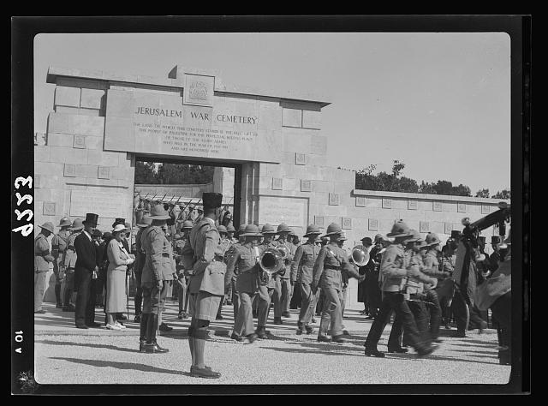

- Child / Young Visitor

Short version:
In this old photograph we see a marching band leaving a war cemetery on Armistice Day. The scene shows respect for soldiers who died and reminds us that war affects many people. [1]
Mid-length version:
The photo, taken in 1936 during the British Mandate in Palestine, shows a military band walking out of the Jerusalem War Cemetery on Mount Scopus on Armistice Day, the day that marks the end of World War I. [1]
It invites us to think about memory: why do we honour people who died in wars? It helps us remember that even when wars are in the past, their effects remain.

For an Adult Visitor

Taken by the American Colony (Jerusalem) photo department and catalogued in the Library of Congress (Matson Photo Service collection), the image titled “Palestine disturbances 1936. Military Band leaving the Jerusalem War Cemetery (i.e., Cemetery) on Armistice Day (Mount Scopus)” evidences the interweaving of colonial military rituals and local political tensions. [1][2]
The cemetery itself, established for Commonwealth war-dead, stands as a symbol of British Imperial sacrifice, while the date (Armistice Day) situates the event in the culture of remembrance. [3]
Understanding this photograph invites reflection on how memorial practices take place in contested terrains, and how such rituals may overlap with unrest.

For a Researcher / Graduate Student

The photograph “Palestine disturbances 1936. Military Band leaving the Jerusalem War Cemetery (Mount Scopus) on Armistice Day” (Matson Photo Service / Library of Congress, LC-DIG-matpc-18236) captures a moment of ceremonial commemoration set within a colonial landscape undergoing profound tension [1]. The timing (November 11, 1936) coincides with Armistice Day, the British Empire’s annual ritual of remembrance for its First World War dead, and it occurs at the height of the Arab Revolt (1936–1939), the largest anti-colonial uprising in Mandate Palestine [1][5].

The site, the Jerusalem War Cemetery on Mount Scopus, established by the Commonwealth War Graves Commission (CWGC) after WWI, was a spatial assertion of imperial permanence and sacred memory [3]. The CWGC’s architectural language, symmetry, stone uniformity, and English inscriptions, codified a British imperial aesthetic of mourning that was both universal and hierarchical. The 1936 ceremony thus functioned not merely as remembrance but as imperial reaffirmation, projecting British legitimacy through ritual in a period of colonial fragility.

The Matson Photo Service, successor to the American Colony Photography Department, had become an important visual instrument in circulating images of both order and unrest [1][2]. Its photographs frequently juxtaposed the disciplined imagery of imperial authority with glimpses of local resistance or disorder. Within this visual regime, the military band procession can be read as a performative spectacle of discipline, meant to embody imperial control amid revolt.

From a methodological standpoint, the photograph invites analysis through visual anthropology and colonial photography studies. It illustrates what Elizabeth Edwards calls “the colonial archive of images,” where photographs act as instruments of governance as much as documentation. The caption’s dual emphasis — “Palestine disturbances” and “Armistice Day” — encapsulates the simultaneity of mourning and domination: remembrance of imperial sacrifice staged amidst anti-imperial defiance. [1][3][5].

For a Professor / Expert

The photograph “Palestine disturbances 1936. Military Band leaving the Jerusalem War Cemetery on Armistice Day (Mount Scopus)” (Matson Photo Service, 1936) stands at the intersection of imperial memory, colonial visuality, and insurgent modernity [1][5]. As a cultural artefact, it may be read through frameworks from postcolonial memory studies, visual culture theory, and the anthropology of ritual.

The setting, Mount Scopus, is itself symbolically charged, a topographic vantage that hosted not only the CWGC cemetery [3] but also the Hebrew University (opened 1925) and the British Police Fort. Within this layered geography, the Armistice Day ceremony enacted an imperial “micro-topography of remembrance”: a ritual of belonging by colonial officials in a space otherwise characterized by political estrangement.

The American Colony / Matson photographic enterprise, operating under the aegis of Western missionary and later commercial frameworks, participated in “the disciplinary technology of the photograph.” Through its lens, the British Mandate was represented as simultaneously benevolent and embattled. The controlled composition, disciplined ranks of soldiers, a brass band, and dignitaries, visually contrasts with the “disturbances” alluded to in the image’s archival metadata. This pairing (order vs. unrest) is not incidental: it embodies the imperial optic of governance, wherein spectacle and suppression are co-constitutive [1][5].

The photograph also exemplifies “performative acts of cultural memory.” Armistice Day ceremonies, transplanted from metropolitan Britain to colonial peripheries, enacted collective memory as an imperial performance. In Palestine, such rituals sought to inscribe British sovereignty within local temporalities, turning remembrance into a political assertion of continuity amidst rebellion.

In theoretical terms, the image sits within the “colonial archive” described by Ann Laura Stoler (Professor of Anthropology and Historical Studies): not a neutral repository but a site of epistemic power where the colonial state’s visual economy regulates what may be remembered and how. Here, the archive’s caption “Palestine disturbances” codifies resistance as “disorder,” thereby integrating insurgency into the moral narrative of empire.

From a visual-semiotic perspective, the photograph performs a pictorial discourse of empire. The forward movement of the band, framed against the monumental stone gate inscribed “Jerusalem War Cemetery,” creates a dialectic between the living performance of empire and the architecture of its dead. The bodies in motion (soldiers) and those memorialized (the fallen) together manifest imperial continuity, a visual metaphor for the persistence of colonial power through ritualized memory.

Moreover, this 1936 image prefigures later debates in memory politics: how commemoration intersects with dispossession. Within Palestinian historiography, Mount Scopus would later acquire different meanings, as a demilitarized zone post-1948, and eventually a site of reasserted sovereignty post-1967. Thus, the photograph’s significance extends beyond its moment; it is a palimpsest of colonial memory whose interpretation evolves with each historical layer [3][5]. In teaching or curatorial contexts, the image serves as an exemplary case for exploring how photography mediates the entanglement of ritual, violence, and power. It allows scholars to interrogate how visual archives naturalize authority, and how acts of remembrance in colonial settings simultaneously commemorate empire and silence resistance. [1][3][5].

Sources
[1] Library of Congress – Prints & Photographs Online Catalog, “Palestine disturbances 1936. Military Band leaving the Jerusalem War Cemetry [i.e., Cemetery] on Armistice Day (Mount Scopus)”: https://www.loc.gov/pictures/collection/matpc/item/2019709006/
[2] Wikimedia Commons – File: Palestine disturbances 1936. Military Band leaving the Jerusalem War Cemetry … (Matson Photo Service): https://commons.wikimedia.org/wiki/File%3APalestine_disturbances_1936._Military_Band_leaving_the_Jerusalem_War_Cemetry_%28i.e.%2C_Cemetery%29_on_Armistice_Day_%28Mount_Scopus%29_LOC_matpc.18236.jpg
[3] Commonwealth War Graves Commission – Jerusalem War Cemetery: https://www.cwgc.org/visit-us/find-cemeteries-memorials/cemetery-details/71401/jerusalem-war-cemetery/
[4] Picryl – “Palestine disturbances 1936. Military Band leaving the Jerusalem War Cemetry …”: https://picryl.com/media/palestine-disturbances-1936-military-band-leaving-the-jerusalem-war-cemetry-ac6789
[5] LOC Digital Archive – Palestine Arab Revolt 1936-38 Collection: https://loc.getarchive.net/collections/palestine-arab-revolt-1936

“We Have Our Heritage and Civilisation"

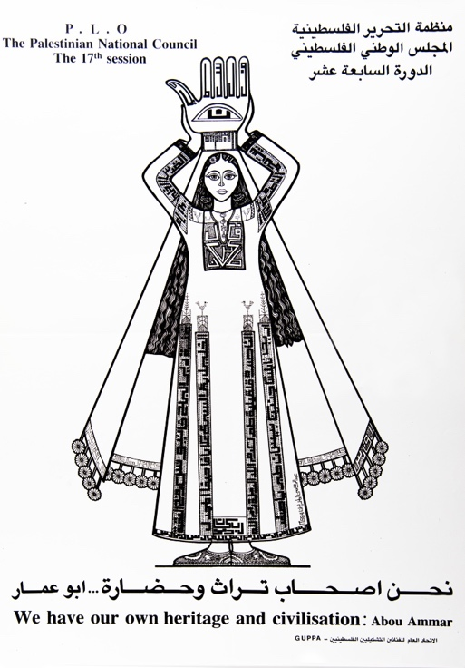

- Child / Young Visitor
Short version:
This poster shows a woman wearing a traditional Palestinian dress, holding a symbol of Palestine above her head. The words say, “We have our own heritage and civilisation.” It tells us that the Palestinian people are proud of their history and culture [1].
Mid-length version:
The picture was made in 1984 by the General Union of Palestinian Plastic Artists (GUPPA) and reproduces an artwork by Abd ar-Rahman al-Muzayyen. The woman in embroidered dress (a thobe) carries above her head a hand-shaped object engraved with the words “Palestine” and “al-Quds” (Jerusalem). The poster says Palestinians have their own culture and history to be proud of [1][2].

For an Adult Visitor
“We Have Our Heritage and Civilisation” is a 1984 poster issued by the General Union of Palestinian Plastic Artists (GUPPA) for the 17th session of the Palestinian National Council. Created by artist Abd ar-Rahman al-Muzayyen, it features a stylized female figure dressed in a richly embroidered traditional Palestinian garment (thobe), symbolizing cultural continuity and resilience. The woman holds above her head a protective hand symbol, inscribed with references to Palestine and al-Quds (Jerusalem), while below appears a declarative slogan attributed to Abu Ammar (Yasser Arafat) affirming, “We have our own heritage and civilisation.” Through this composition, the poster visualizes Palestinian identity as both deeply historical and dynamically modern, linking the aesthetic language of folk embroidery with political assertion. The use of thobe motifs, including the names of Palestinian towns woven into the garment, narrates a visual story of rootedness and belonging, transforming textile heritage into a map of collective memory. Produced during a period of intense identity-building in the late twentieth century, the work embodies the broader movement of visual nationalism, in which artists used popular cultural symbols to articulate the continuity of Palestinian civilization despite displacement and political struggle [1][2][3][4].

For a Researcher / Graduate Student
The poster “We Have Our Heritage and Civilisation” (GUPPA, 1984) stands as a key artefact of Palestinian cultural production in the late twentieth century, revealing how visual language was mobilized to express political identity under conditions of displacement and struggle. Created by Abd ar-Rahman al-Muzayyen and issued by the General Union of Palestinian Plastic Artists (GUPPA) for the 17th session of the Palestinian National Council, the work exemplifies the convergence of art, nationalism, and collective memory within the institutional framework of the PLO’s cultural policy [1][3]. The central composition portrays a woman in a richly embroidered traditional dress (thobe), holding above her head a stylized hand-shaped emblem inscribed with the words “Palestine” and “al-Quds” (Jerusalem) [1]. This image operates within a symbolic system that fuses vernacular craft and political meaning: the embroidered garment functions as both map and archive, transforming textile patterns into a repository of national geography and memory [2]. The hand motif, long a sign of protection in Arab visual culture, acquires new significance here as an emblem of custodianship and sovereignty, the act of bearing the homeland itself [4].
The composition’s linear clarity and symmetry, typical of GUPPA’s print aesthetic, ensure accessibility across linguistic and geographic boundaries, allowing the poster to circulate effectively in the Palestinian diaspora and in solidarity networks abroad [2]. Yet this clarity conceals a complex semiotic structure: the female figure operates simultaneously as a metaphor for the homeland and as an agent of its preservation. The transformation of the woman’s body into a site of cartographic inscription exemplifies what feminist and postcolonial theory describe as the feminization of the nation, a process in which women embody cultural continuity even as their image is idealized and constrained [5].
Produced at a time when Palestinian artists sought to define a distinct modern identity grounded in heritage, the poster participates as the performative construction of nationhood through print and repetition [6]. The slogan, attributed to Abu Ammar (Yasser Arafat) “We have our own heritage and civilisation” translates political ideology into visual rhetoric, asserting that culture itself constitutes a form of resistance and legitimacy [1][3]. By emphasizing historical depth and civilizational continuity, the work responds directly to colonial narratives that sought to deny Palestinian historicity [4]. Viewed within the corpus of GUPPA’s output, including companion works such as Our Roots Extend Deep in Our Land , this poster demonstrates how Palestinian visual culture transformed folk iconography into a modern national semiotic system [5]. Its combination of traditional dress, sacred symbolism, and revolutionary text embodies what might be termed a vernacular modernism: a synthesis of indigenous aesthetic forms and political modernity.
For researchers, the poster offers an exemplary case of how visual art operates as a mode of historical writing. Its production, circulation, and preservation, documented in the Ali Kazak Collection and the Palestinian Museum Digital Archive (Palarchive) [1] provide valuable entry points into studying how political institutions and artists collaborated to construct a transnational cultural identity.

For a Professor / Expert

The poster “We Have Our Heritage and Civilisation” (GUPPA, 1984) exemplifies how Palestinian visual culture in the late twentieth century transformed heritage into a strategic discourse of legitimacy and resistance. Produced by Abd ar-Rahman al-Muzayyen under the auspices of the General Union of Palestinian Plastic Artists (GUPPA) for the 17th Palestinian National Council, the work operates as both a political declaration and a visual archive [1][3]. The composition situates a monumental female figure, frontal and symmetrical, whose embroidered thobe is traversed by the names of Palestinian towns, a textile topography that converts domestic craftsmanship into the geography of belonging [1][4]. The figure lifts above her head a hand-shaped vessel inscribed “Palestine” and “al-Quds”, fusing devotional symbolism with territorial claim [1]. This iconography embodies a complex semiotic matrix. The female body, monumentalized and idealized, enacts what postcolonial feminist theory identifies as the allegorization of the nation, woman as land, mother, and custodian of heritage [5]. The image both celebrates and instrumentalizes femininity, rendering it the surface upon which national continuity is inscribed. Such duality invites critical reflection: the work recuperates women as bearers of cultural transmission while simultaneously fixing them within a symbolic economy of purity and tradition [5][6].
Aesthetically, the poster belongs to the repertoire of resistance graphics that characterized the Palestinian liberation movement from the late 1960s through the 1980s. this period marked the “golden age” of the political poster, during which visual media became a primary site of ideological articulation [2]. The stylistic clarity of line, saturated color fields, and bilingual typography align the work with GUPPA’s institutional project of creating an internationally intelligible iconography of Palestinian modernity [4]. Through such imagery, the PLO’s cultural apparatus sought to project an image of civilization, progress, and legitimacy in global forums, countering Orientalist representations that depicted Palestinian identity as ahistorical or derivative [3][5].
The bilingual inscription, Arabic above, English below, underscores the poster’s dual audience. The Arabic asserts linguistic sovereignty and internal solidarity, while the English translation serves as diplomatic visual rhetoric, addressing foreign publics and affirming the universality of Palestinian culture [1][4]. This linguistic layering exemplifies the performative articulation of the nation, where repetition and translation produce identity across temporal and spatial divides [6].
From a historiographical standpoint, the poster must also be read through the archival frameworks analyzed by Ann Laura Stoler and Ariella Azoulay, who regard archives not as neutral repositories but as arenas of power and resistance [6]. It is not simply a document but an active agent within what Stoler calls the colonial archive’s counter-narrative grain, an artefact that resists erasure by inscribing Palestinian civilization within visual history [6]. In this sense, GUPPA’s practice converts the aesthetics of remembrance into epistemic defiance. Interpreted within the broader field of postcolonial memory studies, the work dramatizes the politics of visibility: to depict is to assert existence. The poster’s preservation within the Ali Kazak Collection and its cataloguing in the Palestinian Museum Digital Archive (Palarchive) ensure its continued role as a visual document of cultural endurance [1]. Comparative analysis with other GUPPA works and with the Palestine Poster Project Archive reveals a coherent aesthetic program: to reclaim heritage as both cultural right and political argument [6][7].

Sources
[1] Palestinian Museum Digital Archive / Palarchive – “We Have Our Heritage and Civilisation” (GUPPA, 1984):
https://www.palarchive.org/index.php/Detail/objects/49/lang/en_US
[2] PalQuest / The Palestinian Poster – Historical Overview and “Golden Age” Context:
https://palquest.palestine-studies.org/en/highlight/10528/palestinian-poster
[3] Palestinian Museum – Object Metadata (GUPPA Poster Collection):
https://palmuseum.wordpress.com/2022/01/29/highlight-of-the-month-2-2/
[4] Loophole Art – “Palestinian Revolutionary Posters: Voices of Resistance and Resilience”:
https://loophole.art/articles/palestinian-revolutionary-posters
[5] PalArchive – “Our Roots Extend Deep in Our Land” (Another GUPPA Poster):
https://www.palarchive.org/index.php/Detail/objects/16260/lang/en_US
[6] Palestine Poster Project Archive – Context and Scholarly Overview:
https://remotearchives.commons.gc.cuny.edu/the-palestine-post-project-archive/
[7] History Today – “Behold Palestine: Posters of the Revolution”:
https://www.historytoday.com/miscellanies/behold-palestine-posters-revolution

“Palestinian refugees”

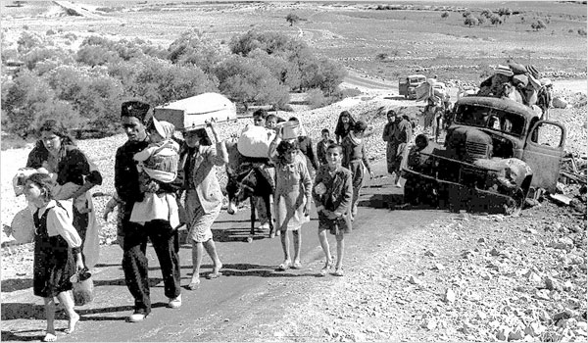

- Child / Young Visitor

This picture shows a group of people walking on a long, dusty road. They are carrying their belongings, bags, blankets, and even small children, because they have had to leave their homes. These are Palestinian families who became refugees in 1948, during a time when war reached their towns and villages [1]. Many of them thought they would return home after a few days, but they were never allowed to go back. The image tells the story of sadness and strength: even when they lost everything, the people kept walking together, helping each other, and hoping for peace [2]. It reminds us that being a refugee means losing a home but not losing the dream of returning someday.

For an Adult Visitor

The photograph titled “Palestinian Refugees” captures a defining moment in the history of the 1948 Palestinian exodus, known in Arabic as the Nakba (“catastrophe”) [1]. Taken during the first Arab-Israeli war, it shows families, men, women, and children, forced to leave their villages and travel on foot across harsh terrain, carrying whatever they could. Abandoned vehicles on the roadside signal the chaos and suddenness of their flight. Historical estimates suggest that over 700,000 Palestinians were displaced in 1948, many seeking refuge in neighboring countries or temporary camps under the care of the United Nations Relief and Works Agency (UNRWA) [2]. The image embodies both the trauma of exile and the enduring resilience of those who survived. It stands as one of the most reproduced visual symbols of the Palestinian refugee experience, appearing in numerous historical archives, exhibitions, and educational materials about forced displacement [3].

For a Researcher / Graduate Student
The photograph “Palestinian Refugees” (1948) documents one of the most significant and enduring episodes of forced migration in the modern Middle East. Preserved in the Wikimedia Commons archive and attributed to United Nations photographers documenting the aftermath of the 1948 Arab–Israeli War [1], the image portrays a line of civilians, primarily women and children, moving away from their destroyed villages. The stark composition, with a derelict truck on the roadside and a barren landscape stretching into the horizon, visually encapsulates the rupture of displacement. It functions not merely as documentation but as a visual metaphor for the Nakba, the mass expulsion and flight of approximately 750,000 Palestinians between 1947 and 1949 [2]. Within the field of visual historiography, this photograph can be read as part of a larger corpus of images produced by international agencies, journalists, and later by UNRWA, whose mandate included the care and registration of refugees [3]. The aesthetic of endurance, the procession, the road, the collective movement, has become a recurring motif in representations of exile and statelessness. Scholars such as Ilan Pappé and Rashid Khalidi have interpreted such imagery as a form of “visual testimony,” one that corroborates oral histories of expulsion and challenges narratives that sought to minimize the scope of the displacement [4]. The photograph also participates in the formation of the “geography of loss,” where exile is not only physical but epistemic: the erasure of presence through maps, texts, and images [5]. As later analyses by UNRWA and the Palestinian Museum Digital Archive demonstrate, these early photographs became central to constructing a collective memory of dispossession [6].

For a Professor / Expert
The photograph “Palestinian Refugees” (1948) stands as an archetypal visual document of the Nakba, integral to both historical narrative and representational politics. Its provenance within United Nations photographic archives situates it at the intersection of documentary evidence and institutional witnessing [1]. The image depicts an exodus, a linear procession of displaced Palestinians traversing a rural landscape punctuated by an abandoned vehicle, the detritus of modernity juxtaposed with the endurance of human motion. The framing recalls the iconography of biblical migration while simultaneously functioning as modern political testimony. From a historiographical perspective, the photograph embodies “the civil contract of photography,” wherein the act of viewing entails an ethical relation between subject and spectator [4]. The image renders visible the political production of refugees, not as incidental casualties but as structural outcomes of the 1948 war. UNRWA’s early reports documented similar scenes as part of an effort to quantify and humanize displacement, thereby institutionalizing a visual grammar of humanitarianism [3]. Within academic discourse, this visual archive has been repeatedly reinscribed in debates over evidence, memory, and denial, especially in the works of Benny Morris, Ilan Pappé, and Walid Khalidi, whose archival studies corroborate the photographic record with declassified military documents [2][5].
The photograph’s composition itself invites semiotic analysis: the diagonal ascent of the road connotes both exile and endurance, while the juxtaposition of wreckage and movement suggests the dialectic of destruction and survival. Read through the lens of postcolonial theory, the image resists closure; it signifies a condition of perpetual displacement that continues to shape Palestinian identity and geopolitics. The persistence of this image in digital archives underscores its function as a living artefact of contested memory [6][7].

Sources
[1] Wikimedia Commons – “Palestinian Refugees” (Public Domain Image, UN Photographer, 1948): https://commons.wikimedia.org/wiki/File:Palestinian_refugees.jpg
[2] UNRWA – “Palestine Refugees: Overview and Historical Context”:https://www.unrwa.org/palestine-refugees
[3] United Nations Archives – “Records of the United Nations Conciliation Commission for Palestine, 1948–1951”: https://archives.un.org/content/united-nations-conciliation-commission-palestine
[4] Pappé, Ilan. The Ethnic Cleansing of Palestine. Oneworld Publications, 2006.
[5] Said, Edward. The Question of Palestine. Vintage Books, 1992.
[6] Palestinian Museum Digital Archive – “Nakba and Refugee Collections”: https://palarchive.org/
[7] Al Jazeera – “Palestine Remix: Visual History of the Nakba”: https://interactive.aljazeera.com/aje/palestineremix

“Palestine refugees flee across the Allenby Bridge during the 1967 hostilities”

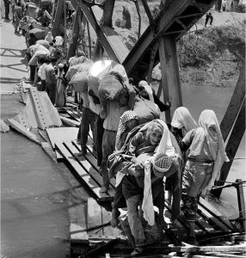

- Child / Young Visitor

This picture shows a group of people walking across a damaged bridge, carrying their bags and children. They are Palestinian families escaping from their homes during the war in 1967, known as the Naksa, which means “setback” in Arabic [1]. Many people had to leave everything behind when fighting began, hoping they could return soon. The bridge they are crossing is called the Allenby Bridge, and it connects the West Bank to Jordan [1][2]. Even though the journey looks hard and dangerous, the people keep walking together. The photograph reminds us that when people lose their homes, they still carry their memories, families, and hope for a better future [3].

For an Adult Visitor

The image “Palestine refugees flee across the Allenby Bridge during the 1967 hostilities” captures the human dimension of the 1967 Arab–Israeli War, known in the Palestinian narrative as the Naksa or “setback.” As the Israeli army advanced into the West Bank, thousands of Palestinian civilians fled across the Jordan River via the Allenby Bridge, seeking refuge in Jordan [1]. The photograph, preserved in the UNRWA photographic archives, records this moment of mass displacement and the collapse of everyday life. According to UNRWA estimates, nearly 300,000 Palestinians were displaced during and after the conflict, with many becoming refugees for the second time, having already fled their homes in 1948 [2]. The image’s stark composition, a line of people balancing over a damaged bridge, conveys both physical danger and emotional endurance. It stands as a visual testament to the recurring cycles of loss that define Palestinian refugee history [3][4].

For a Researcher / Graduate Student

The photograph “Palestine refugees flee across the Allenby Bridge during the 1967 hostilities” (UNRWA Archives, 1967) constitutes one of the most iconic visual records of the Naksa, the second major Palestinian displacement following the 1948 Nakba [1]. As Israeli forces occupied the West Bank, Gaza Strip, Sinai, and Golan Heights in June 1967, an estimated 250,000 to 300,000 Palestinians were uprooted from their homes, with approximately 120,000 crossing into Jordan via the Allenby Bridge [2]. Captured by UNRWA’s official photographers, the image exemplifies the organization’s dual function as a humanitarian agency and historical archive: documenting suffering while also constructing the visual lexicon of displacement [3]. From an analytical perspective, the photograph’s geometry, the diagonal line of refugees traversing the precarious bridge, visually dramatizes the civil contract of photography: the shared space of vulnerability between those who are seen and those who witness [4]. The image performs a dual role, as evidence of crisis and as an enduring icon of Palestinian statelessness. Its publication across UN platforms and later in exhibitions curated by UNESCO and the Palestinian Museum Digital Archive illustrates how institutional photography both humanizes and memorializes refugeehood [5]. Methodologically, the photograph invites inquiry into the relationship between visual evidence and historical narrative. Scholars such as Rashid Khalidi and Benedict Anderson have emphasized how visual archives function as mechanisms of nation formation and collective memory, particularly in stateless contexts [6]. In this sense, UNRWA’s photographic collection, including this image, does more than document displacement: it visualizes continuity, recording not only the movement of bodies but the persistence of community under duress. For graduate-level research, the image offers a critical entry point into examining humanitarian photography, archival power, and the aesthetics of forced migration [3][4][6].

For a Professor / Expert

The photograph “Palestine refugees flee across the Allenby Bridge during the 1967 hostilities” (UNRWA, 1967) stands as a paradigmatic instance of humanitarian visuality within the politics of exile. Taken in the immediate aftermath of the Six-Day War, the image depicts Palestinians crossing the Allenby Bridge, a symbolic and material threshold between war and exile [1]. Within the context of visual historiography, this scene articulates the governed visibility of refugees, where subjects of suffering become objects of administrative documentation [4].

UNRWA’s photography division, established shortly after 1950, developed a visual rhetoric that oscillated between humanitarian aid and political record-keeping [3]. By 1967, its imagery had crystallized into a representational template: the line of movement, the burden of possessions, the bridge as liminal space. The Allenby Bridge photograph, therefore, is not merely descriptive but discursive, encoding the visual grammar through which the Palestinian refugee condition has been globally recognized. Its circulation across UN platforms, and later within digital archives such as UNRWA’s Photo and Film Collection and UNESCO’s “Memory of the World” registry, reinforces its role as both documentary and emblem [3][5].

For scholars of postcolonial visual studies, the photograph encapsulates the entanglement between empire, mobility, and representation. The bridge itself becomes a metaphor for transitional identity, the crossing from citizen to refugee, from visibility to marginality. Interpreted through Edward Said’s notion of exile as a dialectic of memory and displacement, the image resists closure: the refugees’ movement signifies not only loss but also continuity, the persistence of collective identity through migration [6].

Moreover, the image’s compositional austerity — the repetition of covered heads, the tension between structure and void, aligns with the “aesthetic of suffering,” wherein photography oscillates between empathy and voyeurism [7]. Its enduring reproduction in educational, curatorial, and digital contexts testifies to its transformation from journalistic evidence into a visual monument of statelessness.[3][5][7].

Sources
[1] UNRWA – “The Power of the Image: Preserving UNRWA’s Past and Present for the Future” (Official Feature, 2022): https://www.unrwa.org/newsroom/features/power-image-preserving-unrwa%E2%80%99s-past-and-present-future
[2] Britannica – “Arab-Israeli Wars: The Six-Day War (1967)”: https://www.britannica.com/event/Six-Day-War
[3] UNESCO – “UNRWA Photo and Film Archives of Palestinian Refugees (Memory of the World Register)”:https://www.unesco.org/en/memory-world/unrwa-photo-and-film-archives-palestinian-refugees
[4] Azoulay, Ariella – “The Civil Contract of Photography”, MIT Press (2008).
[5] Palestinian Museum Digital Archive – “UNRWA Collections: Refugees of 1948 and 1967”:https://palarchive.org/
[6] Khalidi, Rashid – “Palestinian Identity: The Construction of Modern National Consciousness”, Columbia University Press (2010).
[7] Sontag, Susan – “Regarding the Pain of Others”, Farrar, Straus and Giroux (2003).

“Members from Ayyash family eating food”

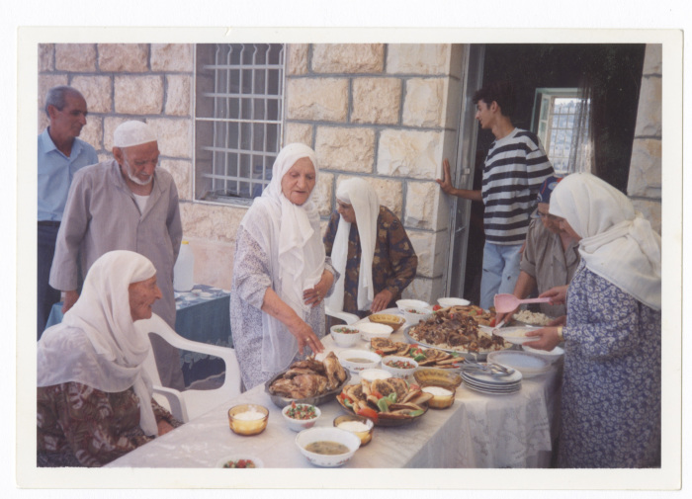

- Child / Young Visitor

This picture shows a family sharing a meal together. The people are from the Ayyash family, and they are eating traditional Palestinian food outside their home [1]. You can see dishes filled with rice, meat, salad, and bread; foods that are often made during special occasions or family gatherings. In Palestine, eating together is more than just having food; it is a way to show love, respect, and togetherness. The photo reminds us how families stay close, celebrate their traditions, and share joy through food, even when life around them is not always easy [2].

- For an Adult Visitor

The photograph “Members from Ayyash family eating food” depicts a moment of family gathering and traditional cuisine in Palestine [1]. Around the table, elders and younger members share dishes that reflect Palestinian culinary culture (roasted chicken, rice, hummus, and salads) meals deeply rooted in both agricultural life and communal values. Such images preserve the essence of domestic and social continuity amidst political instability. In Palestinian culture, food is not simply sustenance but an expression of identity, hospitality, and heritage, passed down through generations [2][3]. The image’s warmth contrasts with the often-dominant representations of exile and conflict, showing that Palestinian life continues through the everyday, in kitchens, family tables, and shared traditions [4].

- For a Researcher / Graduate Student

The photograph “Members from Ayyash family eating food” (PalArchive Collection, late 20th century) provides a valuable ethnographic record of Palestinian domestic and social practices [1]. While political imagery dominates much of Palestinian visual history, this image of a multi-generational family meal foregrounds the persistence of ordinary life and cultural continuity within the framework of displacement and occupation. The dishes presented (rice, roasted meats, bread, and salads) correspond to the agrarian heritage of the West Bank, where foodways are intimately connected to land, season, and locality [2].
Within visual anthropology, such scenes are read as acts of cultural resistance: the preservation of custom and communal ritual as a form of asserting belonging. Scholars have emphasized how domestic photography in Palestine performs an alternative historiography, documenting resilience through the everyday [3]. The photograph’s composition, elderly women at the center, engaged in serving and preparing food, highlights the gendered dimension of cultural transmission, where women act as custodians of memory and heritage [4].
The image connects to the growing scholarship on food, memory, and nationhood. As UNESCO and local institutions like the Palestinian Heritage Museum have documented, traditional cuisine plays a central role in sustaining intangible cultural heritage under threat [5]. The PalArchive’s curation of such family photographs.[1][3][5].

- For a Professor / Expert
The photograph “Members from Ayyash family eating food” (PalArchive, 20th century) operates as an ethnographic tableau of Palestinian domesticity and social reproduction. It captures the relational fabric of family life, a group gathered around a table laden with traditional dishes, situating everyday practice within a matrix of heritage and resistance [1]. The image’s archival context, part of the Palestinian Museum Digital Archive, reconfigures domestic photography from private memory to national testimony, embodying the potential history of the photograph, an unfinished act of witnessing and survival [4]. In terms of socio-cultural analysis, the photograph exemplifies the politics of continuity: while much of Palestinian iconography revolves around exile and dispossession, here the domestic space itself becomes a site of persistence. The shared meal enacts what Salim Tamari describes as “the moral economy of the household,” where social bonds and historical consciousness are reproduced through ritualized acts of hospitality [3]. The presence of elder women, positioned as central figures in the scene, signifies the gendered transmission of heritage, a recurring motif in Palestinian ethnography and oral history [4]. From a theoretical standpoint, the photograph invites readings through the lens of cultural anthropology and visual studies. It aligns with Pierre Bourdieu’s notion of habitus, where everyday practices, here, the preparation and sharing of food, encode social meaning and historical structure. At the same time, within postcolonial frameworks, the domestic setting serves as a counter-archive to narratives of loss: it visualizes endurance through ordinariness. The documentation of such moments by the PalArchive represents a conscious effort to construct a collective archive of intangible heritage, in dialogue with international heritage frameworks such as UNESCO’s Convention for the Safeguarding of Intangible Cultural Heritage [5]. This image offers a locus for analyzing how the quotidian becomes political. It foregrounds how acts of eating, sharing, and remembering transform into modes of resistance, and how photography mediates between the intimate and the collective, between family memory and the broader historiography of Palestinian identity [3][5]

Sources
[1] Palestinian Museum Digital Archive – “Members from Ayyash family eating food”: https://palarchive.org/index.php/Detail/objects/41419/lang/en_US
[2] Britannica – “Palestinian Cuisine and Cultural Traditions”: https://www.britannica.com/topic/Palestine/Cultural-life
[3] Tamari, Salim – “Mountain against the Sea: Essays on Palestinian Society and Culture” (Institute for Palestine Studies, 2009).
[4] Azoulay, Ariella – “Potential History: Unlearning Imperialism” (Verso, 2019).
[5] UNESCO – “Convention for the Safeguarding of the Intangible Cultural Heritage”: https://ich.unesco.org/en/convention

“Children Festival”

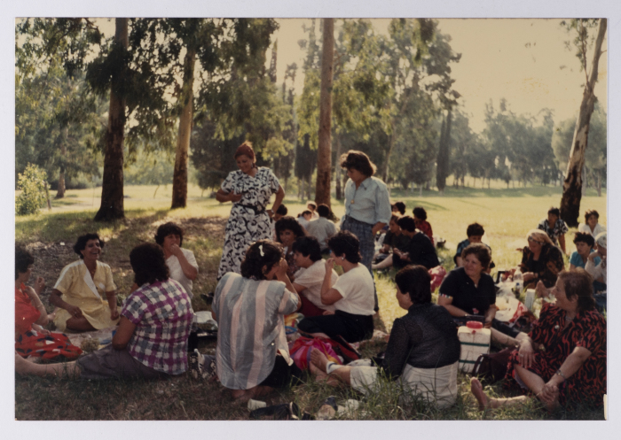

- Child / Young Visitor

This picture shows women sitting together on the grass, sharing food, and enjoying a sunny day. It was taken during the Children Summer Camp in al-Judeida, 1989,in Palestine, where people gathered to celebrate, talk, and spend time outdoors [1]. You can see women chatting, laughing, and preparing snacks for the children. In Palestine, festivals like this are moments of happiness and togetherness, where people remember their traditions and show that joy and community are part of everyday life. That reminds us that even when life can be difficult, families still find ways to celebrate and care for one another [2].

- For an Adult Visitor

The photograph “Children Festival” documents a social gathering held outdoors, during the Children Summer Camp in al-Judeida, 1989, a community event celebrating children and family life in Palestine [1]. The image portrays women sitting together on the grass, sharing food and conversation, an act that reflects both cultural hospitality and the value of collective celebration. In Palestinian social life, such gatherings reinforce family bonds and serve as expressions of cultural continuity [2]. Events like these also highlight the resilience of communities under occupation, emphasizing the persistence of joy, play, and normalcy in spite of hardship. As cultural commentators note, public festivals in Palestine have historically provided spaces for communal identity and social solidarity, combining recreation with a reaffirmation of shared heritage [3]. The image thus becomes more than documentation; it’s a celebration of endurance and togetherness through ordinary joy.

- For a Researcher / Graduate Student

The photograph “Children Festival” (Children Summer Camp in al-Judeida, 1989) is a valuable ethnographic record of Palestinian social and cultural life, revealing the persistence of communal traditions within contexts of political constraint [1]. The image’s focus on women seated outdoors beneath trees, engaged in conversation and shared eating, visualizes what anthropologist Lila Abu-Lughod describes as the “politics of everyday life,” where cultural reproduction occurs through small, familiar acts that sustain collective identity [4]. Within Palestinian society, public festivals and community picnics have historically served as semi-formal cultural spaces where social cohesion, gender roles, and generational ties are enacted and negotiated [3]. This photograph, archived by the Palestinian Museum Digital Archive, belongs to a larger corpus of domestic and civic images that counterbalance the dominant iconography of conflict and displacement. In doing so, it asserts the continuity of Palestinian cultural life as a form of resilience, what anthropologist Salim Tamari has termed “the moral geography of ordinary existence” [5]. From a methodological standpoint, the photograph invites inquiry into the relationship between visual anthropology and social memory. The very act of documenting everyday leisure contributes to an alternative historiography, one grounded not in exceptional events but in the endurance of community life. The framing of the scene, informal, intimate, and dynamic, suggests the democratization of visual culture in post-1970s Palestine, when local photographers and community groups began to record their own narratives independent of international media [6].[4].

- For a Professor / Expert

The “Children Festival” photograph was taken during Children Summer Camp in al-Judeida, 1989, and operates as a crucial artefact within the visual ethnography of Palestinian everyday life, shifting the representational paradigm from trauma to cultural persistence [1]. It depicts an intergenerational social gathering, women seated on grass, engaged in conversation and food-sharing, within an open landscape that functions simultaneously as leisure space and symbolic territory. The photograph exemplifies a civil gaze: an image that constructs citizenship and community through the ordinary rather than the spectacular [7]. In historiographical terms, this image challenges the dominance of conflict-centered photography by foregrounding social intimacy as a site of national endurance. Domestic and communal photography in Palestine operates as an archive of “social continuity,” documenting practices of togetherness that resist the fragmentation of displacement [5]. The image also aligns with Lila Abu-Lughod’s anthropological framework, where women’s gatherings and everyday performances of care are read as “micro-politics of belonging,” enacting nationhood through the domestic sphere [4]. From a theoretical lens, the photograph participates in the vernacular modernity of postcolonial identity, where cultural forms evolve through repetition and adaptation rather than rupture [8]. The picnic setting itself, blending urban and rural aesthetics, reflects changing class and gender dynamics in Palestinian society during the late 20th century, when women’s public participation in community events increased significantly [2][5]. The Children Festival photograph presents a critical nexus for interdisciplinary reflection. It exemplifies how visual vernaculars of ordinariness, the representation of everyday gestures and informal sociability, can reconstitute collective identity through repetition and continuity [7]. At the same time, it demonstrates how gendered social practices, particularly women’s roles in nurturing and sustaining community networks, serve as enduring sites of historical continuity within Palestinian society [4][5]. The photograph also illustrates the function of archival mediation, where domestic and civic images transform private memory into collective historiography, effectively bridging personal experience and national narrative [1][9]. Its analytical richness lies precisely in its restraint: the absence of overt political symbolism renders the image all the more political, turning acts of leisure and conviviality into implicit assertions of existence [5][7].

Sources
[1] Palestinian Museum Digital Archive – “Children Festival”
https://palarchive.org/index.php/Detail/objects/133520/lang/en_US
[2] Britannica – “Palestinian Culture and Society”
https://www.britannica.com/place/Palestine/Cultural-life
[3] Al Jazeera – “How Palestinians Keep Their Culture Alive Through Festivals”
https://www.aljazeera.com/features/2022/3/27/palestinian-culture-through-festivals
[4] Abu-Lughod, Lila – “Remaking Women: Feminism and Modernity in the Middle East” (Princeton University Press, 1998) [Online excerpt: https://press.princeton.edu/books/paperback/9780691058940/remaking-women]
[5] Tamari, Salim – “Mountain Against the Sea: Essays on Palestinian Society and Culture” (Institute for Palestine Studies, 2009).
[6] Palestinian Museum – “Everyday Life and Visual Memory: The Domestic Archive Project”
https://www.palmuseum.org/
[7] Azoulay, Ariella – “Civil Imagination: A Political Ontology of Photography” (Verso, 2012).
[8] Bhabha, Homi K. – “The Location of Culture” (Routledge, 1994).
[9] UNESCO – “Memory of the World: Palestinian Documentary Heritage”
https://www.unesco.org/en/memory-world

“A Scene from Daily Life, Beirut”

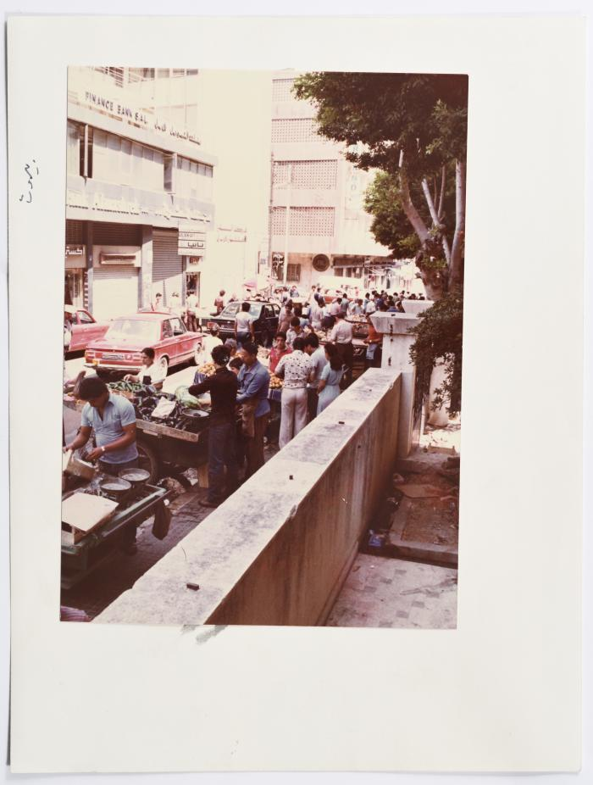

- Child / Young Visitor

This picture shows people living their daily lives in Beirut, Lebanon, during a time of war in 1982 [1]. Even though the city was hurt by bombs and fighting, children still played, families talked, and people tried to go on with their normal routines. It shows that even when things around them were dangerous, people kept their courage and helped each other. The life continues even in hard times, and that kindness, friendship, and hope can still exist during war [2].
- For an Adult Visitor

The photograph “A Scene from Daily Life, Beirut” captures a moment of resilience amid the 1982 Lebanon War, when Israeli forces invaded Beirut and besieged areas populated by both Lebanese civilians and Palestinian refugees [1][3]. Taken in a city under bombardment, the image focuses not on destruction but on the continuity of everyday life, people moving, conversing, and maintaining ordinary routines despite fear. It conveys the paradox of normality within catastrophe, showing that acts as simple as walking to the market or sharing a meal become gestures of survival. For many Palestinians and Lebanese residents, daily life in 1982 Beirut meant improvising new ways to protect family, find food, and maintain dignity [2]. As UNRWA and humanitarian reports from that period describe, civilians organized communal support networks in shelters and courtyards, turning crisis into cooperation [4].

- For a Researcher / Graduate Student

The photograph “A Scene from Daily Life, Beirut” (PalArchive, 1982) offers a crucial ethnographic lens on urban survival and cultural resilience during the Lebanese Civil War, particularly the Israeli invasion and siege of Beirut between June and September 1982 [1][3]. The image, devoid of overt political iconography, represents the civil space of photography, where ordinary citizens become witnesses to their own endurance through the act of being seen [5]. From a historical standpoint, the war’s impact on Beirut’s urban fabric was devastating entire districts, including Sabra and Shatila, were destroyed, yet daily life persisted through adaptive routines, street markets, improvised classrooms, shared meals, forming the stubborn normality of Beirutis [6]. The photograph’s composition, focusing on civilian activity rather than militarized imagery, challenges conventional war photography that privileges spectacle over lived experience. Within the context of Palestinian visual culture, this image also resonates with the diasporic experience of displacement. Many of Beirut’s residents at the time were Palestinian refugees who had fled the 1948 Nakba and later conflicts [4]. The coexistence of war and routine in the frame visually articulates the infrastructures of endurance, the everyday systems and relationships that allow communities to survive prolonged instability [7]. Analytically, the photograph functions as both document and metaphor: it records a specific historical conjuncture while symbolizing the broader continuity of civilian life amid repeated crises. [3][5][7].

- For a Professor / Expert

The “A Scene from Daily Life, Beirut” photograph (PalArchive, 1982) constitutes a critical artefact within the visual historiography of Middle Eastern conflict, capturing the quotidian persistence of life amid the siege of Beirut. In contrast to the journalistic aesthetics of devastation prevalent in the global press at the time, this image belongs to civil photography, a practice that articulates citizenship through visibility rather than sovereignty [5]. It situates the ordinary citizen, rather than the militant or the victim, as the central subject of historical witness.
Taken during the Israeli invasion of Lebanon in June 1982, the photograph documents a moment in which urban existence became an act of resistance [1][3]. Beirut, functioned as both a battlefield and a city of endurance, where social rituals meals, neighborhood gatherings, casual encounters, persisted within the architecture of ruins [6]. In this sense, the image visualizes what Edward Said later termed the aesthetics of steadfastness: the assertion of cultural continuity amid fragmentation.
The photograph’s ethnographic density lies in its ability to bridge Palestinian and Lebanese experiences of displacement. By 1982, tens of thousands of Palestinians resided in Beirut’s camps such as Shatila, transforming the city into a microcosm of exile [4][7]. Within this interwoven social fabric, acts of everyday life, children walking to school, families gathering in courtyards, became micro-political assertions of humanity, echoing Lila Abu-Lughod’s framework of the politics of everyday life [8].
From a theoretical standpoint, the photograph participates in the postcolonial discourse of the urban, revealing how modern Arab cities internalize and resist the spatial logic of militarization. Its subdued tone and non-dramatic framing reject spectacle, aligning instead with critique of “war’s seduction of the eye,” in favor of an ethics of witnessing [9]. The image, thus, is not merely illustrative but discursive: it invites reflection on how visual archives mediate trauma and how local photographers contribute to counter-narratives of survival.
the Beirut Daily Life image transforms the mundane into a mode of historical narration.

Sources
[1] Palestinian Museum Digital Archive – “A Scene from Daily Life, Beirut”
https://palarchive.org/index.php/Detail/objects/309177/lang/en_US
[2] Britannica – “Lebanon: Civil War and Israeli Invasion (1975–1990)”
https://www.britannica.com/place/Lebanon/Civil-war-and-Israeli-invasion
[3] Al Jazeera – “Remembering the 1982 Lebanon War”
https://www.aljazeera.com/news/2022/6/6/remembering-the-1982-lebanon-war
[4] UNRWA – “Palestine Refugees in Lebanon: Historical Overview”
https://www.unrwa.org/where-we-work/lebanon
[5] Azoulay, Ariella – “The Civil Contract of Photography” (MIT Press, 2008).
[6] Kassir, Samir – “Beirut” (University of California Press, 2010).
[7] Khalili, Laleh – “Heroes and Martyrs of Palestine: The Politics of National Commemoration” (Cambridge University Press, 2007).
[8] Abu-Lughod, Lila – “The Politics of Everyday Life in the Middle East” (Princeton University Press, 1998).
[9] Sontag, Susan – “Regarding the Pain of Others” (Farrar, Straus and Giroux, 2003).
[10] UNESCO – “Memory of the World: Palestinian Documentary Heritage”
https://www.unesco.org/en/memory-world

